STROKE PREDICTION USING MACHINE LEARNING

____________________

##### 

##### 

##### 

##### 

##### **STROKE PREDICTION USING MACHINE LEARNING**

##### **A Major Project Report**

***in partial fulfilment for the award of the degree***

***of***

##### **BACHELOR’s OF TECHNOLOGY**

***In***

**COMPUTER SCIENCE ENGINEERING**

###### **by**

##### **MAYANK SINGH, PRITIKA RANA and SHIVAM RATHI**

**Guided by**

**Dr SUNITA TIWARI**

**Assistant. Professor**



**DEPARTMENT OF COMPUTER SCIENCE AND ENGINEERING**

**G.B. PANT GOVT. ENGINEERING COLLEGE, NEW DELHI.**

(AFFILIATED TO GURU GOBIND SINGH INDRAPRASTHA UNIVERSITY, DELHI)

**MAY, 2021**

**CANDIDATE’S DECLARATION**

I hereby certify that the work which is being presented in the Major Project entitled **“Stroke Prediction Using Machine Learning”** in partial fulfilment for the award of the Degree of Bachelor of Technology in Computer Science and Engineering / Information Technology affiliated to **Guru Gobind Singh Indraprastha University, New Delhi** and submitted to the Department of Computer Science and Engineering G. B. Pant Govt. Engineering College is an authentic record of my work carried out during a period from March 2021 to May 2021. The matter represented in this report has not been submitted by me for the award of any other degree of this or any other institute/university.

**Date: - 10-05-2021 Name and Roll No:**

**Mayank Singh (00420907218)**

**Pritika Rana (02420902717)**

**Shivam Rathi (03220902717)**

This is to certify that the above statement made by the candidate is correct to the best of our knowledge.

#### *Signature of Supervisor*

#### **Date: - Name & Designation**

**TABLE OF CONTENTS**

**CHAPTER NO. TITLE PAGE NO.**

**LIST OF FIGURES i**

**ACKNOWLEDGMENT iii**

**ABSTRACT iv**

**CHAPTER 1. INTRODUCTION 1**

1.1 OVERVIEW 1

1.2 MOTIVATION 1

1.3 PROBLEM STATEMENT 1

1.4 SCOPE OF PROJECT 1

1.5 ACCESS TO USERS 2

**CHAPTER 2. RELATED WORKS 3**

2.1 INTRODUCTION 3

2.2 EXISTING SYSTEM 3

2.3 PROPOSED SYSTEM 4

2.3.1 IMAGE FEATURE EXTRACTION 4

2.3.2 THE LANGUAGE MODEL 5

2.3.3 FITTING THE MODEL 6

2.3.4 CAPTION GENERATION 6

2.3.5 SUGGESTION API 6

**CHAPTER 3. PROBLEM DESCRIPTION & SPECIFICATION 7**

3.1 PROBLEM OVERVIEW 7

3.2 SPECIFICATION 7

3.3 REQUIREMENTS 8

3.3.1 SOFTWARE REQUIREMENTS 8

3.3.2 HARDWARE REQUIREMENTS 8

3.3.3 OTHER REQUIREMENTS 9

**CHAPTER 4. SYSTEM DESIGN 10**

4.1 INTRODUCTION 10

4.1.1 DATA SOURCES 10

4.1.2 CONVOLUTION NEURAL NETWORK 10

4.1.3 RECURRENT NEURAL NETWORK 11

4.2 ARCHITECTURE DIAGRAM 11

4.3 UML DIAGRAM 12

4.4 DATA FLOW DIAGRAM 14

4.5 FLOW CHART DIAGRAM14

**CHAPTER 5. IMPLEMENTATION AND RESULT 16**

5.1 INTRODUCTION 16

5.2 MODEL SELECTION 16

5.3 IMAGE PREPROCESSING 17

5.4 TEXT PREPROCESSING 19

5.5 CREATING VOCABULARY 21

5.6 PREPARING THE MODEL 23

5.7 CONFIGURING THE MODEL 25

5.8 TRAINING AND SAVING THE MODEL 28

5.9 PREDICTING THE CAPTIONS 29

5.10 WEB PAGE DEVELOPMENT 31

5.11 API INTEGRATION 32

5.12 PROVIDING USER WITH CAPTIONS32

**CHAPTER 6. CONCLUSION AND FUTURE SCOPE 34**

6.1 CONCLUSION 34

6.2 FUTURE SCOPE34

**CHAPTER 7. REFERENCES 36**

**APPENDICES 39**

**APPENDIX 1: DETAILED TEST STRATEGY AND TEST CASES 39**

**APPENDIX 2: USER GUIDE 40**

**List of Figures**

**Figure No. Figure Title Page No.**

1 Flow Diagram of the project 8

2 Architecture of the image captioning model 11

3 Illustration image of functioning of the captioning model 12

4 Use Case Diagram for the captioning system 12

5 DFD Level 0 13

6 DFD Level 1 13

7 DFD Level 2 14

8 State Chart Diagram of the system 14

9 Flow chart for the caption generation process 15

10 Code Snippet showing the selection and adjustment of the model 16

11 Output representing different layers of the selected model 17

12 Code snippet showing preprocessing of images 17

13 A sample picture fetched from the dataset 18

14 Code snippet - Extracting feature map from passed images 18

15 Output representing the process of feature map creations 19

16 Code snippet showing text preprocessing 20

17 Sample captions fetched from Flickr8k.token.txt 20

18 Code snippet showing the process of caption dictionary creation 21

19 Sample view of caption dictionary 21

20 Code snippet showing Vocabulary Creation Process 22

21 Sample output showing the count of different words 22

22 Sample output showing the word dictionary 23

23 Sample output showing the integer form captions 23

24 Code snippet showing the max length of the caption present 24

25 Output showing the length of the largest caption in our collection 24

26 Code snippet showing the input preparation for the model 24

27 Code snippet showing the conversion to NumPy array form 25

28 Sample output showing the shapes of input 25

29 Configuring process of the image and language model 26

30 Output showing the image sequential model 26

31 Output showing the language sequential model 27

32 Output showing the combined mode 27

33 Detailed layout of the model along with shapes of inputs 28

34 Code snippet showing the training process 29

35 Sample output of the training process 29

36 Sample output of the inverse dictionary 29

37 Code snippet showing the image preprocessing for testing 30

38 Code snippet showing the prediction process and results 30

39 Some sample results generated by the model 31

40 Layout of the Home page of the Web App 33

41 Sample final results on the Web Platform 33

A1 Sample image showing loss and accuracy obtained by the model 38

**ACKNOWLEDGEMENT**

I would like to express my sincere gratitude to my supervisor’s **Dr Sunita Tiwari** & **Dr Anu Saini** for providing their invaluable guidance, comments and suggestions throughout the project. I would specially thank Dr Sunita Tiwari for constantly motivating me to work harder and suggesting me different ways to tackle the problems encountered.

Also, I would like to thank my team members for their assistance in the project. I would like to express my gratitude for the Department of Computer Science Engineering, Gobind Ballabh Pant Government Engineering college to provide me with the opportunity to work on this project and to all the teachers and mentors guiding along the way.

* Mayank Singh (00420907218)
* Pritika Rana (02420902717)
* Shivam Rathi (03220902717)

**ABSTRACT**

The project Stroke Prediction Using Machine Learning provides user an ability to check the chances of stroke to him/her, based on different parameters asked to him/her. The user interacts with the project with the help of a Web Platform which contains a form having different key parameters which constitutes in stroke. On providing these inputs the model predicts the chances of stroke to him/her.

Stroke is a deadly disease and a leading cause of death. In most of the case the patient suffers grave consequences, along with the patient the family and relatives also suffer a lot. But studies suggest that 80 percent of stroke can be pre-diagnosed and, in that scenario, patient can be saved. There are some key parameters which contributes to chances of stroke. There parameter includes age, gender, hypertension, blood pressure, heart disease, average glucose level, BMI, smoking habits, work type, place of residence, marital status, previous history of stroke or heart attack etc. of the patient. As a patient is mostly well aware of these factors, he/she can get a diagnosis in the case of suspicion about chances of stroke. A lot of machine learning methods are developed and are currently under research to predict the chances of stroke based on different parameters.

In this project we have taken 10 different machine learning classifiers and tested them on our dataset “Stroke dataset” for accuracy. Then selected the best one for prediction. We have also performed k-fold validation and hyper-parameter optimization on the model. Along with that we have tried to identify the best features for the classifiers. The inputs gathered from user via the web platform is provided to the model using the flask backend system and the saved model is used for predicting the output which is displayed to the user on the result page.

The project provides user the facility to check the chances of stroke to them based on inputs features at the choice of location and time through their web enabled devices. The project will be hosted online on web app or mobile app and can be used by user from anywhere. Along with this our objective is also to compare various machine learning algorithm and learn how they perform on the dataset for predicting the stroke risk. What are differences among different model and also understand which classifiers performs best and what may be the reasons behind it.

**CHAPTER-1**

**INTRODUCTION**

**1.1 OVERVIEW**

# **Stroke: -**

A stroke occurs when the blood supply to part of your brain is interrupted or reduced, preventing brain tissue from getting oxygen and nutrients. Brain cells begin to die in minutes. Stroke is a medical emergency, and prompt treatment is crucial. Early action can reduce brain damage and other complications. It is the fifth leading cause of death in the United States and a leading of death even in India. In fact, nearly 800,000 people have a stroke each year. That equates to around one person every 40 seconds.

Signs and symptoms of a stroke may include an [inability to move or feel](https://en.wikipedia.org/wiki/Hemiplegia) on one side of the body, [problems understanding](https://en.wikipedia.org/wiki/Receptive_aphasia) or [speaking](https://en.wikipedia.org/wiki/Expressive_aphasia), [dizziness](https://en.wikipedia.org/wiki/Dizziness), or [loss of vision to one side](https://en.wikipedia.org/wiki/Homonymous_hemianopsia). Signs and symptoms often appear soon after the stroke has occurred. If symptoms last less than one or two hours, the stroke is a [transient ischemic attack](https://en.wikipedia.org/wiki/Transient_ischemic_attack) (TIA), also called a mini-stroke. A [hemorrhagic stroke](https://en.wikipedia.org/wiki/Subarachnoid_hemorrhage) may also be associated with a [severe headache](https://en.wikipedia.org/wiki/Thunderclap_headache). The symptoms of a stroke can be permanent. Long-term complications may include [pneumonia](https://en.wikipedia.org/wiki/Pneumonia) and [loss of bladder control](https://en.wikipedia.org/wiki/Urinary_incontinence).

[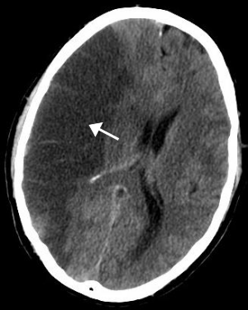](https://en.wikipedia.org/wiki/File:MCA_Territory_Infarct.svg)

Figure 1 [CT scan](https://en.wikipedia.org/wiki/CT_scan) of the brain showing a prior right-sided [ischemic](https://en.wikipedia.org/wiki/Ischemic) stroke from blockage of an artery. Changes on a CT may not be visible early on.

The main [risk factor](https://en.wikipedia.org/wiki/Risk_factor) for stroke is [high blood pressure](https://en.wikipedia.org/wiki/Hypertension). Other risk factors include [tobacco smoking](https://en.wikipedia.org/wiki/Tobacco_smoking), [obesity](https://en.wikipedia.org/wiki/Obesity), [high blood cholesterol](https://en.wikipedia.org/wiki/Hypercholesterolemia), [diabetes mellitus](https://en.wikipedia.org/wiki/Diabetes_mellitus), a previous TIA, [end-stage kidney disease](https://en.wikipedia.org/wiki/End-stage_kidney_disease), and [atrial fibrillation](https://en.wikipedia.org/wiki/Atrial_fibrillation).

There are three main types of stroke:

**Ischemic stroke**

This is the most common type of stroke, making up 87% of all cases. A blood clot prevents blood and oxygen from reaching an area of the brain. It happens when the brain's blood vessels become narrowed or blocked, causing severely reduced blood flow (ischemia). Blocked or narrowed blood vessels are caused by fatty deposits that build up in blood vessels or by blood clots or other debris that travel through your bloodstream and lodge in the blood vessels in your brain

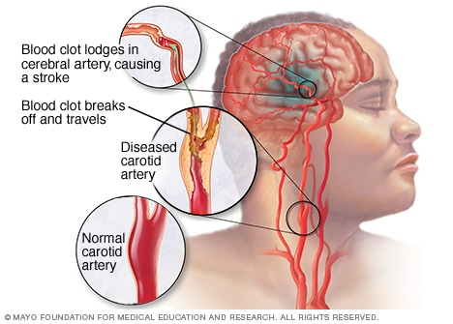

**Hemorrhagic stroke**

Hemorrhagic stroke occurs when a blood vessel in your brain leaks or ruptures. Brain hemorrhages can result from many conditions that affect your blood vessels. These are usually the result of aneurysms (an *aneurysm* refers to a weakening of an artery wall that creates a bulge, or distention, of the artery). Factors related to hemorrhagic stroke include:

* Uncontrolled high blood pressure
* Overtreatment with blood thinners (anticoagulants)
* Bulges at weak spots in your blood vessel walls (aneurysms)
* Trauma (such as a car accident)
* Protein deposits in blood vessel walls that lead to weakness in the vessel wall (cerebral amyloid angiopathy)
* Ischemic stroke leading to hemorrhage

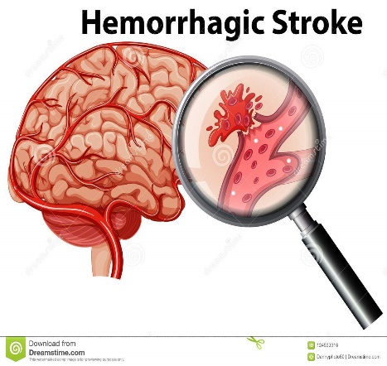

**Transient ischemic attack (TIA)**

This occurs when blood flow to a part of the brain is inadequate for a brief period of time. It is a temporary period of symptoms similar to those you'd have in a stroke. Normal blood flow resumes after a short amount of time, and the symptoms resolve without treatment. Some people call this a [ministroke](https://www.medicalnewstoday.com/articles/164038.php). A TIA doesn't cause permanent damage. They're caused by a temporary decrease in blood supply to part of your brain, which may last as little as five minutes.

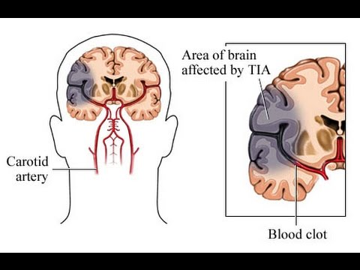

Prevention includes decreasing risk factors, [surgery to open up the arteries to the brain](https://en.wikipedia.org/wiki/Carotid_endarterectomy) in those with problematic [carotid narrowing](https://en.wikipedia.org/wiki/Carotid_stenosis), and [warfarin](https://en.wikipedia.org/wiki/Warfarin) in people with [atrial fibrillation](https://en.wikipedia.org/wiki/Atrial_fibrillation). [Aspirin](https://en.wikipedia.org/wiki/Aspirin) or [statins](https://en.wikipedia.org/wiki/Statin) may be recommended by physicians for prevention. A stroke or TIA often requires emergency care.

**An ischemic stroke, if detected within three to four and half hours, may be treatable with a** [**medication**](https://en.wikipedia.org/wiki/Thrombolytic_drug) **that can** [**break down the clot**](https://en.wikipedia.org/wiki/Thrombolysis)**.** Some hemorrhagic strokes benefit from [surgery](https://en.wikipedia.org/wiki/Neurosurgery). Treatment to attempt recovery of lost function is called [stroke rehabilitation](https://en.wikipedia.org/wiki/Stroke_rehabilitation), and ideally takes place in a stroke unit; however, these are not available in much of the world.

In 2013, approximately 6.9 million people had an ischemic stroke and 3.4 million people had a hemorrhagic stroke. In 2015, there were about 42.4 million people who had previously had a stroke and were still alive. Between 1990 and 2010 the number of strokes which occurred each year decreased by approximately 10% in the [developed world](https://en.wikipedia.org/wiki/Developed_world) and increased by 10% in the developing world. In 2015, stroke was the second most [frequent cause of death](https://en.wikipedia.org/wiki/List_of_causes_of_death_by_rate) after [coronary artery disease](https://en.wikipedia.org/wiki/Coronary_artery_disease), accounting for 6.3 million deaths (11% of the total). About 3.0 million deaths resulted from ischemic stroke while 3.3 million deaths resulted from hemorrhagic stroke. About half of people who have had a stroke live less than one year. Overall, two thirds of strokes occurred in those over 65 years old.

**Classification**

[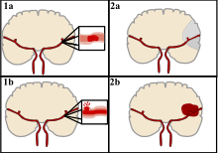](https://en.wikipedia.org/wiki/File:Ischemic_Stroke.svg)

There are two main categories of strokes. Ischemic (top), typically caused by a blood clot in an artery (1a) resulting in brain death to the affected area (2a). Hemorrhagic (bottom), caused by blood leaking into or around the brain from a ruptured blood vessel (1b) allowing blood to pool in the affected area (2b) thus increasing the pressure on the brain.

[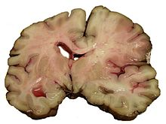](https://en.wikipedia.org/wiki/File:MCA-Stroke-Brain-Human-2.JPG)

A slice of brain from the autopsy of a person who had an acute [middle cerebral artery (MCA)](https://en.wikipedia.org/wiki/Middle_cerebral_artery) stroke

Strokes can be classified into two major categories: [ischemic](https://en.wikipedia.org/wiki/Ischemia) and [hemorrhagic](https://en.wikipedia.org/wiki/Bleeding). Ischemic strokes are caused by [interruption of the blood supply](https://en.wikipedia.org/wiki/Perfusion#Malperfusion) to the brain, while hemorrhagic strokes result from the rupture of a [blood vessel](https://en.wikipedia.org/wiki/Blood_vessel) or an [abnormal vascular structure](https://en.wikipedia.org/wiki/Cerebral_arteriovenous_malformation). About 87% of strokes are ischemic, the rest being hemorrhagic. Bleeding can develop inside areas of ischemia, a condition known as "hemorrhagic transformation." It is unknown how many hemorrhagic strokes actually start as ischemic strokes.

### **Definition**

In the 1970s the [World Health Organization](https://en.wikipedia.org/wiki/World_Health_Organization) defined stroke as a "neurological deficit of cerebrovascular cause that persists beyond 24 hours or is interrupted by death within 24 hours" although the word "stroke" is centuries old. This definition was supposed to reflect the reversibility of tissue damage and was devised for the purpose, with the time frame of 24 hours being chosen arbitrarily. The 24-hour limit divides stroke from [transient ischemic attack](https://en.wikipedia.org/wiki/Transient_ischemic_attack), which is a related syndrome of stroke symptoms that resolve completely within 24 hours. With the availability of treatments that can reduce stroke severity when given early, many now prefer alternative terminology, such as brain attack and acute ischemic cerebrovascular syndrome (modeled after [heart attack](https://en.wikipedia.org/wiki/Myocardial_infarction) and [acute coronary syndrome](https://en.wikipedia.org/wiki/Acute_coronary_syndrome), respectively), to reflect the urgency of stroke symptoms and the need to act swiftly.

### **Ischemic**

In an ischemic stroke, blood supply to part of the brain is decreased, leading to dysfunction of the brain tissue in that area. There are four reasons why this might happen:

1. [Thrombosis](https://en.wikipedia.org/wiki/Thrombosis) (obstruction of a blood vessel by a blood clot forming locally)
2. [Embolism](https://en.wikipedia.org/wiki/Embolism) (obstruction due to an [embolus](https://en.wikipedia.org/wiki/Embolus) from elsewhere in the body),
3. Systemic hypoperfusion (general decrease in blood supply, e.g., in [shock](https://en.wikipedia.org/wiki/Shock_(circulatory)))
4. [Cerebral venous sinus thrombosis](https://en.wikipedia.org/wiki/Cerebral_venous_sinus_thrombosis).

A stroke without an obvious explanation is termed [cryptogenic](https://en.wikipedia.org/wiki/Idiopathic_disease) (of unknown origin); this constitutes 30–40% of all ischemic strokes.

### **Hemorrhagic**

[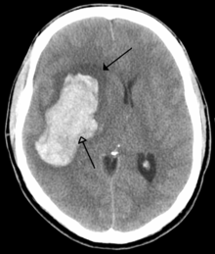](https://en.wikipedia.org/wiki/File:Parachemableedwithedema.png)

[CT scan](https://en.wikipedia.org/wiki/CT_scan) of an intraparenchymal bleed (bottom arrow) with surrounding edema (top arrow)

There are two main types of hemorrhagic stroke:

* [Intracerebral hemorrhage](https://en.wikipedia.org/wiki/Intracerebral_hemorrhage), which is basically bleeding within the brain itself (when an artery in the brain bursts, flooding the surrounding tissue with blood), due to either [intraparenchymal hemorrhage](https://en.wikipedia.org/wiki/Intraparenchymal_hemorrhage) (bleeding within the brain tissue) or [intraventricular hemorrhage](https://en.wikipedia.org/wiki/Intraventricular_hemorrhage) (bleeding within the brain's [ventricular system](https://en.wikipedia.org/wiki/Ventricular_system)).
* [Subarachnoid hemorrhage](https://en.wikipedia.org/wiki/Subarachnoid_hemorrhage), which is basically bleeding that occurs outside of the brain tissue but still within the skull, and precisely between the [arachnoid mater](https://en.wikipedia.org/wiki/Arachnoid_mater) and [pia mater](https://en.wikipedia.org/wiki/Pia_mater) (the delicate *innermost* layer of the three layers of the [meninges](https://en.wikipedia.org/wiki/Meninges) that surround the brain).

The above two main types of hemorrhagic stroke are also two different forms of [intracranial hemorrhage](https://en.wikipedia.org/wiki/Intracranial_hemorrhage), which is the accumulation of blood anywhere within the [cranial vault](https://en.wikipedia.org/wiki/Cranial_vault); but the other forms of intracranial hemorrhage, such as [epidural hematoma](https://en.wikipedia.org/wiki/Epidural_hematoma) (bleeding between the skull and the [dura mater](https://en.wikipedia.org/wiki/Dura_mater), which is the thick *outermost* layer of the meninges that surround the brain) and [subdural hematoma](https://en.wikipedia.org/wiki/Subdural_hematoma) (bleeding in the [subdural space](https://en.wikipedia.org/wiki/Subdural_space)), are not considered "hemorrhagic strokes".

Hemorrhagic strokes may occur on the background of alterations to the blood vessels in the brain, such as [cerebral amyloid angiopathy](https://en.wikipedia.org/wiki/Cerebral_amyloid_angiopathy), [cerebral arteriovenous malformation](https://en.wikipedia.org/wiki/Cerebral_arteriovenous_malformation) and an [intracranial aneurysm](https://en.wikipedia.org/wiki/Intracranial_aneurysm), which can cause intraparenchymal or subarachnoid hemorrhage.[[*citation needed*](https://en.wikipedia.org/wiki/Wikipedia:Citation_needed)]

In addition to neurological impairment, hemorrhagic strokes usually cause specific symptoms (for instance, subarachnoid hemorrhage classically causes a severe [headache](https://en.wikipedia.org/wiki/Headache) known as a [thunderclap headache](https://en.wikipedia.org/wiki/Thunderclap_headache)) or reveal evidence of a previous [head injury](https://en.wikipedia.org/wiki/Head_injury).

## **Signs and symptoms**

Stroke symptoms typically start suddenly, over seconds to minutes, and in most cases do not progress further. The symptoms depend on the area of the brain affected. The more extensive the area of the brain affected, the more functions that are likely to be lost. Some forms of stroke can cause additional symptoms. For example, in intracranial hemorrhage, the affected area may compress other structures. Most forms of stroke are not associated with a [headache](https://en.wikipedia.org/wiki/Headache), apart from subarachnoid hemorrhage and cerebral venous thrombosis and occasionally intracerebral hemorrhage.

### **Early recognition**

Various systems have been proposed to increase recognition of stroke. Different findings are able to predict the presence or absence of stroke to different degrees. **Sudden-onset face weakness, arm drift (i.e., if a person, when asked to raise both arms, involuntarily lets one arm drift downward) and abnormal speech are the findings most likely to lead to the correct identification of a case of stroke, increasing the likelihood by 5.5 when at least one of these is present**. Similarly, when all three of these are absent, the likelihood of stroke is decreased (– [likelihood ratio](https://en.wikipedia.org/wiki/Likelihood_ratios_in_diagnostic_testing) of 0.39). While these findings are not perfect for diagnosing stroke, the fact that they can be evaluated relatively rapidly and easily make them very valuable in the acute setting.

In most cases, the symptoms affect only one side of the body (unilateral). Depending on the part of the brain affected, the defect in the brain is *usually* on the [opposite side](https://en.wikipedia.org/wiki/Contralateral) of the body. However, since these pathways also travel in the [spinal cord](https://en.wikipedia.org/wiki/Spinal_cord) and any lesion there can also produce these symptoms, the presence of any one of these symptoms does not necessarily indicate a stroke. In addition to the above CNS pathways, the [*brainstem*](https://en.wikipedia.org/wiki/Brainstem) gives rise to most of the twelve [cranial nerves](https://en.wikipedia.org/wiki/Cranial_nerves). A [brainstem stroke](https://en.wikipedia.org/wiki/Brainstem_stroke_syndrome) affecting the brainstem and brain, therefore, can produce symptoms relating to deficits in these cranial nerves:[[*citation needed*](https://en.wikipedia.org/wiki/Wikipedia:Citation_needed)]

* altered smell, taste, hearing, or vision (total or partial)
* drooping of eyelid ([ptosis](https://en.wikipedia.org/wiki/Ptosis_(eyelid))) and weakness of [ocular muscles](https://en.wikipedia.org/wiki/Extraocular_muscles)
* decreased reflexes: gag, swallow, pupil reactivity to light
* decreased sensation and muscle weakness of the face
* [balance problems](https://en.wikipedia.org/wiki/Balance_disorder) and [nystagmus](https://en.wikipedia.org/wiki/Nystagmus)
* altered breathing and heart rate
* weakness in [sternocleidomastoid muscle](https://en.wikipedia.org/wiki/Sternocleidomastoid_muscle) with inability to turn head to one side
* weakness in tongue (inability to stick out the tongue or move it from side to side)

If the [*cerebral cortex*](https://en.wikipedia.org/wiki/Cerebral_cortex) is involved, the CNS pathways can again be affected, but also can produce the following symptoms:

* [aphasia](https://en.wikipedia.org/wiki/Aphasia) (difficulty with verbal expression, auditory comprehension, [reading](https://en.wikipedia.org/wiki/Alexia_(condition)) and [writing](https://en.wikipedia.org/wiki/Agraphia); [Broca's](https://en.wikipedia.org/wiki/Broca's_area) or [Wernicke's area](https://en.wikipedia.org/wiki/Wernicke's_area) typically involved)
* [dysarthria](https://en.wikipedia.org/wiki/Dysarthria) ([motor speech disorder](https://en.wikipedia.org/wiki/Motor_speech_disorders) resulting from neurological injury)
* [apraxia](https://en.wikipedia.org/wiki/Apraxia) (altered voluntary movements)
* [visual field](https://en.wikipedia.org/wiki/Visual_field) defect
* memory deficits (involvement of [temporal lobe](https://en.wikipedia.org/wiki/Temporal_lobe))
* [hemineglect](https://en.wikipedia.org/wiki/Hemineglect) (involvement of [parietal lobe](https://en.wikipedia.org/wiki/Parietal_lobe))
* disorganized thinking, confusion, [hypersexual](https://en.wikipedia.org/wiki/Hypersexual) gestures (with involvement of frontal lobe)
* [lack of insight](https://en.wikipedia.org/wiki/Anosognosia) of his or her, usually stroke-related, disability

If the [*cerebellum*](https://en.wikipedia.org/wiki/Cerebellum) is involved, [ataxia](https://en.wikipedia.org/wiki/Ataxia#Cerebellar) might be present and this includes:

* altered walking [gait](https://en.wikipedia.org/wiki/Gait_abnormality)
* altered [movement coordination](https://en.wikipedia.org/wiki/Motor_coordination)
* [vertigo](https://en.wikipedia.org/wiki/Vertigo_(medical)) and or disequilibrium

### **Associated symptoms**

[Loss of consciousness](https://en.wikipedia.org/wiki/Unconsciousness), headache, and vomiting usually occur more often in hemorrhagic stroke than in thrombosis because of the increased [intracranial pressure](https://en.wikipedia.org/wiki/Intracranial_pressure) from the leaking blood compressing the brain.

If symptoms are maximal at onset, the cause is more likely to be a subarachnoid hemorrhage or an embolic stroke.

## **Diagnosis**

[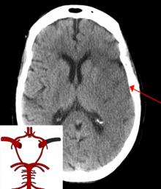](https://en.wikipedia.org/wiki/File:StrokeMCA_overlay.png)

A CT showing early signs of a middle cerebral artery stroke with loss of definition of the gyri and grey white boundary

[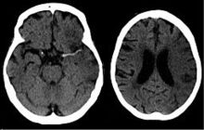](https://en.wikipedia.org/wiki/File:Dens_media_sign_mit_Mediainfarkt_-_CCT_001.jpg)

Dens media sign in a patient with middle cerebral artery infarction shown on the left. Right image after 7 hours.

Stroke is diagnosed through several techniques: a neurological examination (such as the [NIHSS](https://en.wikipedia.org/wiki/NIHSS)), CT scans (most often without contrast enhancements) or [MRI scans](https://en.wikipedia.org/wiki/MRI_scan), [Doppler ultrasound](https://en.wikipedia.org/wiki/Doppler_ultrasound), and [arteriography](https://en.wikipedia.org/wiki/Arteriography). The diagnosis of stroke itself is clinical, with assistance from the imaging techniques. Imaging techniques also assist in determining the subtypes and cause of stroke. There is yet no commonly used [blood test](https://en.wikipedia.org/wiki/Blood_test) for the stroke diagnosis itself, though blood tests may be of help in finding out the likely cause of stroke.

### **Physical examination**

A [physical examination](https://en.wikipedia.org/wiki/Physical_examination), including taking a [medical history](https://en.wikipedia.org/wiki/Medical_history) of the symptoms and a neurological status, helps giving an evaluation of the location and severity of a stroke. It can give a standard score on e.g., the [NIH stroke scale](https://en.wikipedia.org/wiki/NIH_stroke_scale).

### **Imaging**

For diagnosing ischemic (blockage) stroke in the emergency setting:

* CT scans (*without* contrast enhancements)

[sensitivity](https://en.wikipedia.org/wiki/Sensitivity_(tests))= 16% (less than 10% within first 3 hours of symptom onset)

[specificity](https://en.wikipedia.org/wiki/Specificity_(tests))= 96%

* MRI scan

sensitivity= 83%

specificity= 98%

For diagnosing hemorrhagic stroke in the emergency setting:

* CT scans (*without* contrast enhancements)

sensitivity= 89%

specificity= 100%

* MRI scan

sensitivity= 81%

specificity= 100%

For detecting chronic hemorrhages, MRI scan is more sensitive.

For the assessment of stable stroke, nuclear medicine scans SPECT and PET/CT may be helpful. SPECT documents cerebral blood flow and PET with FDG isotope the metabolic activity of the neurons.

CT scans may not detect an ischemic stroke, especially if it is small, of recent onset, or in the brainstem or cerebellum areas. A CT scan is more to *rule out* certain stroke mimics and detect bleeding.

### Underlying cause

[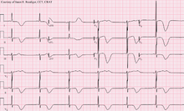](https://en.wikipedia.org/wiki/File:Left_MCA_Stroke.png)

12-lead ECG of a patient with a stroke, showing large deeply inverted [T-waves](https://en.wikipedia.org/wiki/T_wave). Various ECG changes may occur in people with strokes and other brain disorders.

### **Risk factors**

The most important modifiable risk factors for stroke are **high blood pressure** and **atrial fibrillation** although the size of the effect is small with 833 people have to be treated for 1 year to prevent one stroke. Other modifiable risk factors include **high blood cholesterol levels**, [**diabetes mellitus**](https://en.wikipedia.org/wiki/Diabetes_mellitus)**,** [**end-stage kidney disease**](https://en.wikipedia.org/wiki/End-stage_kidney_disease)**, cigarette smoking** (active and passive), **heavy** [**alcohol**](https://en.wikipedia.org/wiki/Alcohol_consumption_and_health) use**, drug use**, **lack of** [**physical activity**](https://en.wikipedia.org/wiki/Physical_activity)**,** [**obesity**](https://en.wikipedia.org/wiki/Obesity)**, processed** [**red meat**](https://en.wikipedia.org/wiki/Red_meat) **consumption, and unhealthy diet**. **Smoking just one cigarette per day increases the risk more than 30%.** Alcohol use could predispose to ischemic stroke, as well as intracerebral and subarachnoid hemorrhage via multiple mechanisms (for example, via hypertension, atrial fibrillation, rebound [thrombocytosis](https://en.wikipedia.org/wiki/Thrombocytosis) and [platelet aggregation](https://en.wikipedia.org/wiki/Platelet_aggregation) and [clotting](https://en.wikipedia.org/wiki/Clotting) disturbances). Drugs, most commonly amphetamines and cocaine, can induce stroke through damage to the blood vessels in the brain and acute hypertension. [Migraine](https://en.wikipedia.org/wiki/Migraine) with [aura](https://en.wikipedia.org/wiki/Aura_(symptom)) doubles a person's risk for ischemic stroke. Untreated, [celiac disease](https://en.wikipedia.org/wiki/Celiac_disease) regardless of the presence of symptoms can be an underlying cause of stroke, both in children and adults.

**High levels of physical activity reduce the risk of stroke by about 26%**. There is a lack of high-quality studies looking at promotional efforts to improve lifestyle factors. Nonetheless, given the large body of circumstantial evidence, best medical management for stroke includes advice on diet, exercise, smoking and alcohol use. Medication is the most common method of stroke prevention; [carotid endarterectomy](https://en.wikipedia.org/wiki/Carotid_endarterectomy) can be a useful surgical method of preventing stroke.

#### **Blood pressure**

[**High blood pressure**](https://en.wikipedia.org/wiki/Hypertension) **accounts for 35–50% of stroke risk**. Blood pressure reduction of 10 mmHg systolic or 5 mmHg diastolic reduces the risk of stroke by ~40%. Lowering blood pressure has been conclusively shown to prevent both ischemic and hemorrhagic strokes. It is equally important in secondary prevention.

#### **Blood lipids**

**High cholesterol levels** have been inconsistently associated with (ischemic) stroke. [**Statins**](https://en.wikipedia.org/wiki/Statins) **have been shown to reduce the risk of stroke by about 15%.**

#### **Diabetes mellitus**

[**Diabetes mellitus**](https://en.wikipedia.org/wiki/Diabetes_mellitus) **increases the risk of stroke by 2 to 3 times.** While intensive blood sugar control has been shown to reduce small blood vessel complications such as [kidney damage](https://en.wikipedia.org/wiki/Diabetic_nephropathy) and [damage to the retina of the eye](https://en.wikipedia.org/wiki/Diabetic_retinopathy) it has not been shown to reduce large blood vessel complications such as stroke.

#### **Diet**

Nutrition, specifically the [Mediterranean-style diet](https://en.wikipedia.org/wiki/Mediterranean_diet), has the potential for decreasing the risk of having a stroke by more than half.

### **Women**

A number of specific recommendations have been made for women including taking aspirin after the 11th week of pregnancy if there is a history of previous chronic high blood pressure and taking blood pressure medications during pregnancy if the blood pressure is greater than 150 mmHg systolic or greater than 100 mmHg diastolic. In those who have previously had [preeclampsia](https://en.wikipedia.org/wiki/Preeclampsia) other risk factors should be treated more aggressively.

### **Previous stroke or TIA**

Keeping blood pressure below 140/90 mmHg is recommended. Anticoagulation can prevent recurrent ischemic strokes. **Among people with nonvalvular atrial fibrillation, anticoagulation can reduce stroke by 60% while antiplatelet agents can reduce stroke by 20%**. However, a recent meta-analysis suggests harm from anticoagulation started early after an embolic stroke. **Stroke prevention treatment for atrial fibrillation is determined according to the** [**CHA2DS2–VASc score**](https://en.wikipedia.org/wiki/CHA2DS2%E2%80%93VASc_score). The most widely used anticoagulant to prevent thromboembolic stroke in people with nonvalvular atrial fibrillation is the oral agent [warfarin](https://en.wikipedia.org/wiki/Warfarin) while a number of newer agents including [dabigatran](https://en.wikipedia.org/wiki/Dabigatran) are alternatives which do not require [prothrombin time](https://en.wikipedia.org/wiki/Prothrombin_time) monitoring.

### **Stroke unit**

Ideally, people who have had a stroke are admitted to a "stroke unit", a ward or dedicated area in a hospital staffed by nurses and therapists with experience in stroke treatment. It has been shown that people admitted to a stroke unit have a higher chance of surviving than those admitted elsewhere in hospital, even if they are being cared for by doctors without experience in stroke. [Nursing care](https://en.wikipedia.org/wiki/Nursing_care) is fundamental in maintaining [skin care](https://en.wikipedia.org/wiki/Skin), feeding, hydration, positioning, and monitoring [vital signs](https://en.wikipedia.org/wiki/Vital_signs) such as temperature, pulse, and blood pressure.

### **Rehabilitation**

[Stroke rehabilitation](https://en.wikipedia.org/wiki/Stroke_rehabilitation) is the process by which those with disabling strokes undergo treatment to help them return to normal life as much as possible by regaining and relearning the skills of everyday living. It also aims to help the survivor understand and adapt to difficulties, prevent secondary complications, and educate family members to play a supporting role. Stroke rehabilitation should begin almost immediately with a multidisciplinary approach. The rehabilitation team may involve physicians trained in rehabilitation medicine, [neurologists](https://en.wikipedia.org/wiki/Neurologist), [clinical pharmacists](https://en.wikipedia.org/wiki/Clinical_pharmacist), nursing staff, [physiotherapists](https://en.wikipedia.org/wiki/Physiotherapist), [occupational therapists](https://en.wikipedia.org/wiki/Occupational_therapist), [speech-language pathologists](https://en.wikipedia.org/wiki/Speech-language_pathology), and [orthotists](https://en.wikipedia.org/wiki/Orthotist). Some teams may also include [psychologists](https://en.wikipedia.org/wiki/Psychologists) and [social workers](https://en.wikipedia.org/wiki/Social_work), since at least one-third of affected people manifests [post stroke depression](https://en.wikipedia.org/wiki/Post_stroke_depression). Validated instruments such as the [Barthel scale](https://en.wikipedia.org/wiki/Barthel_scale) may be used to assess the likelihood of a person who has had a stroke being able to manage at home with or without support subsequent to discharge from a hospital.

[Stroke rehabilitation](https://en.wikipedia.org/wiki/Stroke_rehabilitation) should be started as quickly as possible and can last anywhere from a few days to over a year. Most return of function is seen in the first few months, and then improvement falls off with the "window" considered officially by [U.S. state](https://en.wikipedia.org/wiki/U.S._state) rehabilitation units and others to be closed after six months, with little chance of further improvement. However, some people have reported that they continue to improve for years, regaining and strengthening abilities like writing, walking, running, and talking. Daily rehabilitation exercises should continue to be part of the daily routine for people who have had a stroke. Complete recovery is unusual but not impossible and most people will improve to some extent: proper diet and exercise are known to help the brain to recover.

#### **Physical and occupational therapy**

Physical and occupational therapy have overlapping areas of expertise; however, physical therapy focuses on joint range of motion and strength by performing exercises and relearning functional tasks such as bed mobility, transferring, walking and other gross motor functions. Physiotherapists can also work with people who have had a stroke to improve awareness and use of the [hemiplegic](https://en.wikipedia.org/wiki/Hemiplegic) side. Rehabilitation involves working on the ability to produce strong movements or the ability to perform tasks using normal patterns. Emphasis is often concentrated on functional tasks and people's goals. One example physiotherapists employ to promote [motor learning](https://en.wikipedia.org/wiki/Motor_learning) involves [constraint-induced movement therapy](https://en.wikipedia.org/wiki/Constraint-induced_movement_therapy). Through continuous practice the person relearns to use and adapt the hemiplegic limb during functional activities to create lasting permanent changes. Physical therapy is effective for recovery of function and mobility after stroke. Occupational therapy is involved in training to help relearn everyday activities known as the [activities of daily living](https://en.wikipedia.org/wiki/Activities_of_daily_living) (ADLs) such as eating, drinking, dressing, bathing, cooking, [reading](https://en.wikipedia.org/wiki/Alexia_(condition)) and [writing](https://en.wikipedia.org/wiki/Agraphia), and toileting. Approaches to helping people with urinary incontinence include physical therapy, cognitive therapy, and specialized interventions with experienced medical professionals, however, it is not clear how effective these approaches are at improving urinary incontinence following a stroke.

Treatment of spasticity related to stroke often involves early mobilizations, commonly performed by a physiotherapist, combined with elongation of spastic muscles and sustained stretching through various different positions. Gaining initial improvement in range of motion is often achieved through rhythmic rotational patterns associated with the affected limb. After full range has been achieved by the therapist, the limb should be positioned in the lengthened positions to prevent against further contractures, skin breakdown, and disuse of the limb with the use of splints or other tools to stabilize the joint. Cold in the form of ice wraps or ice packs have been proven to briefly reduce spasticity by temporarily dampening neural firing rates. [Electrical stimulation](https://en.wikipedia.org/wiki/Sensory_stimulation_therapy#Coactivation) to the antagonist muscles or vibrations has also been used with some success. Physical therapy is sometimes suggested for people who experience sexual dysfunction following a stroke.

#### **Speech and language therapy**

[Speech and language therapy](https://en.wikipedia.org/wiki/Speech_and_language_therapy) is appropriate for people with the speech production disorders: [dysarthria](https://en.wikipedia.org/wiki/Dysarthria) and [apraxia of speech](https://en.wikipedia.org/wiki/Apraxia_of_speech), [aphasia](https://en.wikipedia.org/wiki/Aphasia), cognitive-communication impairments, and [problems with swallowing](https://en.wikipedia.org/wiki/Dysphagia). Speech and language therapy for aphasia following stroke compared to no therapy improves functional communication, reading, writing and expressive language. There may be benefit in high intensity and high doses over a longer period, but these higher intensity doses may not be acceptable to everyone.

People who have had a stroke may have particular problems, such as [dysphagia](https://en.wikipedia.org/wiki/Dysphagia), which can cause swallowed material to pass into the lungs and cause [aspiration pneumonia](https://en.wikipedia.org/wiki/Aspiration_pneumonia). The condition may improve with time, but in the interim, a [nasogastric tube](https://en.wikipedia.org/wiki/Nasogastric_intubation) may be inserted, enabling liquid food to be given directly into the stomach. If swallowing is still deemed unsafe, then a [percutaneous endoscopic gastrostomy](https://en.wikipedia.org/wiki/Percutaneous_endoscopic_gastrostomy) (PEG) tube is passed and this can remain indefinitely. Swallowing therapy has mixed results as of 2018.

#### **Devices**

Often, [assistive technology](https://en.wikipedia.org/wiki/Assistive_technology) such as [wheelchairs](https://en.wikipedia.org/wiki/Wheelchairs), walkers and canes may be beneficial. Many mobility problems can be improved by the use of [ankle foot orthoses](https://en.wikipedia.org/wiki/Orthotics#Ankle-foot_orthosis_(AFO)).

#### **Physical fitness**

A stroke can also reduce people's general fitness. Reduced fitness can reduce capacity for rehabilitation as well as general health. Physical exercises as part of a rehabilitation program following a stroke appear safe. Cardiorespiratory fitness training that involves walking in rehabilitation can improve speed, tolerance and independence during walking, and may improve balance. There are inadequate long-term data about the effects of exercise and training on death, dependence and disability after a stroke. The future areas of research may concentrate on the optimal exercise prescription and long-term health benefits of exercise. The effect of physical training on cognition also may be studied further.

The ability to walk independently in their community, indoors or outdoors, is important following stroke. Although no negative effects have been reported, it is unclear if outcomes can improve with these walking programs when compared to usual treatment.

## **Prognosis**

Disability affects 75% of stroke survivors enough to decrease their ability to work. Stroke can affect people physically, mentally, emotionally, or a combination of the three. The results of stroke vary widely depending on size and location of the lesion.

### **Physical effects**

Some of the physical disabilities that can result from stroke include muscle weakness, numbness, [pressure sores](https://en.wikipedia.org/wiki/Pressure_sore), [pneumonia](https://en.wikipedia.org/wiki/Pneumonia), [incontinence](https://en.wikipedia.org/wiki/Urinary_incontinence), [apraxia](https://en.wikipedia.org/wiki/Apraxia) (inability to perform learned movements), difficulties carrying out [daily activities](https://en.wikipedia.org/wiki/Activities_of_daily_living), appetite loss, [speech loss](https://en.wikipedia.org/wiki/Aphasia), [vision loss](https://en.wikipedia.org/wiki/Vision_loss) and [pain](https://en.wikipedia.org/wiki/Pain). If the stroke is severe enough, or in a certain location such as parts of the brainstem, [coma](https://en.wikipedia.org/wiki/Coma) or death can result. Up to 10% of people following a stroke develop [seizures](https://en.wikipedia.org/wiki/Seizure), most commonly in the week subsequent to the event; the severity of the stroke increases the likelihood of a seizure. An estimated 15% of people experience urinary incontinence for more than a year following a stroke. 50% of people have a decline in sexual function ([sexual dysfunction](https://en.wikipedia.org/wiki/Sexual_dysfunction)) following a stroke.

## **Epidemiology**

[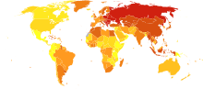](https://en.wikipedia.org/wiki/File:Stroke_world_map-Deaths_per_million_persons-WHO2012.svg)

Stroke deaths per million persons in 2012

  58–316

  317–417

  418–466

  467–518

  519–575

  576–640

  641–771

  772–974

  975-1,683

  1,684–3,477

[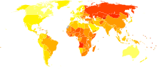](https://en.wikipedia.org/wiki/File:Cerebrovascular_disease_world_map_-_DALY_-_WHO2004.svg)

[Disability-adjusted life year](https://en.wikipedia.org/wiki/Disability-adjusted_life_year) for cerebral vascular disease per 100,000 inhabitants in 2004.[[208]](https://en.wikipedia.org/wiki/Stroke#cite_note-208)

|  |  |
| --- | --- |
| no data    <250    250–425    425–600    600–775    775–950    950–1125 | 1125–1300    1300–1475    1475–1650    1650–1825    1825–2000    >2000 |

Stroke was the second most frequent cause of death worldwide in 2011, accounting for 6.2 million deaths (~11% of the total). Approximately 17 million people had a stroke in 2010 and 33 million people have previously had a stroke and were still alive. Between 1990 and 2010 the number of strokes decreased by approximately 10% in the developed world and increased by 10% in the developing world. Overall, two-thirds of strokes occurred in those over 65 years old. South Asians are at particularly high risk of stroke, accounting for 40% of global stroke deaths.

**The risk of stroke** [**increases exponentially**](https://en.wikipedia.org/wiki/Exponential_growth) **from 30 years of age, and the cause varies by age.** Advanced age is one of the most significant stroke risk factors. **95% of strokes occur in people age 45 and older, and two-thirds of strokes occur in those over the age of 65**. A person's risk of dying if he or she does have a stroke also increases with age. However, stroke can occur at any age, including in childhood.

Family members may have a genetic tendency for stroke or share a lifestyle that contributes to stroke. Higher levels of [Von Willebrand factor](https://en.wikipedia.org/wiki/Von_Willebrand_factor) are more common amongst people who have had ischemic stroke for the first time. The results of this study found that the only significant genetic factor was the person's [blood type](https://en.wikipedia.org/wiki/Blood_type). Having had a stroke in the past greatly increases one's risk of future strokes.

**Men are 25% more likely to suffer strokes than women, yet 60% of deaths from stroke occur in women**. Since women live longer, they are older on average when they have their strokes and thus more often killed. Some risk factors for stroke apply only to women. Primary among these are pregnancy, childbirth, [menopause](https://en.wikipedia.org/wiki/Menopause), and the treatment thereof ([HRT](https://en.wikipedia.org/wiki/Hormone_replacement_therapy_(menopause))).

**1.2 MOTIVATION**

The stroke prediction model provides the chances of stroke to the user. This is done by collecting the inputs from user from the web platform and use the trained model to predict the chance of stroke to the user. It is easy to use and always available and can be accessed from anywhere and anytime through the web enabled device. Whenever a person feels symptoms of stroke like loss in vision in one eye, inability to move or feel on one side of the body, problem in understanding or speaking, dizziness these could be symptoms of stroke. There are some key risk factors like blood pressure, smoking habits, high blood cholesterol, obesity, diabetes, kidney problem etc. which are often know to user. In this case he/she can do a self-diagnosis test for chances for stroke risk to him/her and then consult a doctor. Timely detection can help to a large extend and can even save life in some instances. The easy to access app will provide ease to user. Also, the project will help us understand the capability and factors useful for machine learning classifiers for predicting such results.

**1.3 PROBLEM STATEMENT**

To compare various machine learning classifiers based on accuracy and select the best one to build a system for predicting stroke risk.

**1.4 SCOPE OF PROJECT**

This project provides user will a easy to access app which they can use to check the chances of stroke to them. The aim of the project is to make such app available to everyone. This project also plans to learn which machine learning classifiers are best suited for this kind of job and understand the reason behind it.

**1.5 ACCESS TO USERS**

The project aims to host the web app or mobile app for the users making it easily available for everyone at all time. The interface aims to be very basic and user friendly. The major objective is this app can be used by users on phone instantaneously and does not require any expertise.

**CHAPTER - 2**

**RELATED WORK**

**2.1 INTRODUCTION**

In this section, we will look into some of the earlier works presented in the direction of this project. There has been an extensive amount of work that has already happened in the field of prediction in the medical department. While preparing this project we have gathered ideas from different research materials and models. Here, we are going to enlist them.

**2.2 EXISTING SYSTEM**

Lately a lot of research has been done on predicting strokes. The research can be briefly categorized into three different categories including the dataset collection, algorithm comparison and efficient and accurate stroke rate prediction.

Machine learning, a subfield of Artificial Intelligence including the improvement of calculations that figure out how to make forecasts dependent on information, has various rising applications in the field of bioinformatics. Bioinformatics manages computational and numerical methodologies for comprehension and handling natural data. This multi-layered way to deal with learning designs in the information permits such frameworks to make very intricate forecasts when prepared on enormous datasets. As of late, the size and number of accessible natural datasets have soar, empowering bioinformatics specialists to utilize these Machine learning frameworks. Machine learning strategies for examination of neuro imaging information are utilized to help analyze stroke. Diagnosis and treatment of stroke disease are very complex, developing nations, due to the absence of diagnostic devices as well as a shortage of doctors and many other resources that affect adequate prediction and medication of heart patients. Recently, computer technology and machine learning methods are existence with this concern, to improve the system to support doctors in the preliminary stage in making decisions about disease

Many system have been developed in recent times to for stroke predictions in recent times all differing by small factors. Decision tree is used to select form the given condition on each stage. Principal component analysis is done to work on simpler dimension. Authors stated that because of the increase of the strokes there are many premature death nowadays. We can predict the symptoms of stroke through medical data analytics. We came to know that these and comparative results were an improvement in the quality, accuracy and capability of the stroke prediction.

The existing research is limited in predicting risk factors pertained to various types of strokes. To address this limitation a Stroke Prediction (SPN) algorithm is proposed by using the improvised random forest in analyzing the levels of risks obtained within the strokes. This research of the Stroke Predictor (SPR) model using machine learning techniques improved the prediction accuracy to 96.97% when compared with the existing models.

**Related work**

Yu et al. [16] have implemented the machine learning techniques by considering the decision tree algorithm of C4.5. The proposed methodology of this work uses 13 features rather than 18 stroke scale features for determining and analyzing the stroke classification. The data collected from the database of the National Institutes of Health Stroke Scale (NIHSS) for the study of cerebrovascular strokes among people affected over age 65 years. Out of total samples, 75% of subjects were used for training, and 25% of subjects were used for testing. Based on the hypothetical solutions 91.11% decent accuracy is obtained through the decision tree algorithm.

Monteiro et al. [17] have implemented a machine learning methodology to determine the practical results of the patients affected with ischemic stroke when admitted for three weeks. Among different types of strokes, Ischemic stroke acts as a major purpose of disorder and death all over the world among people of 65 years and in adults. The proposed methodology is succeeded on an outcome of the outlined superior AUC value of 0.808± 0.085 when compared to the foremost point score of 0.771 ± 0.056 with 70% subjects used for training and 30% subjects used for testing. On the other hand, the model keeps on increasing the additional features depending upon particular timing along with the increase in the AUC score by setting the point score of above 0.90. The Baseline feature sets used under experiment -1 produced a ‘good’ outcome with 51.3% and a ‘poor’ outcome with 48.7% accuracies on 425 samples. By obtaining the conclusions and validating the results taken at the time of admission and by making a priority of the use of technological methods whenever required.

Sung et al. [18] have proposed a methodology that can be examined for automated phenotyping by further classifying the ischemic stroke into 4 subdivisions. This model depending upon the structured and unstructured data taken from the electronic medical records (EMRs). It works on the records of 4640 patients who have been diagnosed with the mild symptoms of Ischemic stroke and also been taken for examining the results. The sub-divisions structured data has National Institutes of Health stroke scale whereas unstructured data has clinical narratives which are refined through a heatmap. The conclusion of stroke scale data from EMRs could make the process clear and smooth phenotyping of ischemic stroke when integrated with the structures data. However, diminishing the different levels of class issues into binary classification work along with the congregation of classifies solution helps in increasing the performance by taking 66% subjects on training and 34% subjects on testing.

Xie et al. [19] have proposed a model to combine common stroke biomarkers by developing machine learning techniques and to analyze the complete recovery of the ischemic stroke patient within three months. In this work, to predict the recovery terms of the patient Extreme gradient boosting (XGB) and Gradient Boosting Machine (GBM) models were implemented to identify modified ranking scale (mRS) scores by using biomarkers availability within 24 hours of the admitting of the patient. A total of 512 patients records were taken into consideration for analysis with fivefold cross-validation for identifying the improvements of the model. These records are categorized into 80% on training and 20% on testing. Under the binary analysis of an mRS score which is larger than 2 considering biomarkers which are provided during the time of admitting, XGB and GBM include AUC of scores 0.746 and 0.748 accordingly.

Wang et al. [20] have implemented a machine learning model in the configuration of the risk of symptomatic intracerebral hemorrhage (sICH) after the thrombolysis of the stroke. The risk factors of sICH are theoretically used after stroke thrombolysis. Based on this study, a total of 2578 thrombolysis-treated ischemic stroke patients were recognized from January 2013 and December 2016. Out of which 70% were taken into training modules and 30% considered under nominal data test sets. In order to analyze the risk of sICH, these machine learning modules were helped to increase the performance analysis metrics through the area under curve (AUC) with 0.82.

Lin et al. [21] have proposed a hybrid neural network model with 10 cross folds for evaluating the stroke outcome. The data collected from “Taiwan Stroke Registry” is given for the model with 70% on training and 30% on testing.

Sung et al. [22] have implemented machine learning algorithms to analyze the stroke outcome with acute minor stroke. Among 739 patients, 61 patients having a negative outcome after a stroke at 90 days. The data is categorized into 89.4% for no END and the remaining 10.6% for END This database related to patients was taken from NIHSS with a score of ≤ 3. Pre indication of the neurological deterioration tells us that diminishing of the NIHSS score within days of the admission of the patient. The inimical score was determined from the modified Ranking scale score of ≥ 2. In this work, four machine learning models such as bootstrap decision forest, boosted trees, Logistic Regression, and Deep neural network was used in analyzing the early signs of neurological deterioration and examined with a decent accuracy of 94.6%.

This section comprises of different benchmark machine learning models with their limitations, the dataset used for this research work, and proposed architecture with its advantage over existing models.

**3.1 Machine learning models**

3.1.1 Gaussian Naïve Bayes

Supervised learning algorithm uses the Naïve Bayes Model, which depends on Bayes theorem involves resolving the different divisions of the errors. Among different types of Naive Bayes methodologies, we implement “Gaussian naïve Bayes” in this research work. The probabilities of the patients effected by hemorrhagic and ischemic strokes can be written as:

*P*(*AB*)=∑*w*∈*A*∩*BP*(*WB*)+∑*w*∈*A*∩*BcP*(*WB*)

  (1)

=∑*w*∈*A*∩*BP*(*w*)*P*(*B*)

   (2)

=*P*(*A*∩*B*)*P*(*B*)

   (3)

where, ‘A’ is probability of getting stroke and ‘B’ defines highest occurring value of every primary attribute in dataset.

The instances represented by solution vector x = (x1, x2, x3,……,xn) and P(Ck | x1, x2, x3,……,xn ), where, ‘Ck’ defines the ‘kth’ class and ‘k’ is the number of classes.

The conditional probability of Gaussian Naïve Bayes can be decomposed as follows:

*P*(*Ck*∣x)=*P*(*Ck*)*P*(x∣*Ck*)*P*(x)

   (4)

Using the probability on construction a model classifier is calculated as:

*y*^=argmax{*P*(*c*1)∏*ni*=1*P*(*xiC*1),*P*(*c*2)

∏*ni*=1*P*(*xiC*2)}

   (5)

where, ‘n’ defines number of primary parameters (n=9), ‘C1’ defines the low risk and ‘C2’ defines the high risk.

3.1.2 Linear regression

The name itself is referred to as the precise correspondence among the dependent and independent variables considering few or more variables so-called linear regression. Since the linear regression represents in a precise way in its correspondence by predicting the change in the variables of dependent classes to that of the change of the variables in the independent classes is calculated as:

Y = b0 + b1*X1+ b2*X2 + b3*X3 +……. + bn*Xn (6)

where, ‘Y’ is a dependent variable, X1……Xn are independent variables, b0.….bn are the regression coefficients. The number of attributes ‘n’ is written as:

*Yi*=∑*ni*=1*Xn*∗*bn*+*b*0

   (7)

In this research work, we consider the “Multilinear regression” technique from among the various types of linear regression modules. In general, taking the variables than the required sum in the independent class that is required in analyzing the binary dependent values. This process of linear regression is referred to as Multilinear regression and the sum of squares error (SSE) can be calculated as:

*SSE*=∑(*Yi*−*Y*∣*i*)2

   (8)

where, Yi is ‘Predicted Output’ and *Y*∣*i*

 is ‘expected output’.

3.1.3 Logistic regression

Logistic regression comes under the technique of supervised learning, which is used for analyzing the absolute dependent values by making use of the variable among the required blocks of the independent values. Analysis of the output values can be determined by the logistic regression of the absolute dependent values. Hence the solutions can be drawn as the absolute or the differential variables. It may be of any form either numerical or binary variables i.e., Yes or No, 0 or 1, true or false, etc. In the computer-determined language, the values are given in the 0 or a format but this model represents the feasible value that lies between 0 and 1. The usage of the values is the only difference between Logistic regression and Linear Regression. The retrogradation of the problems can be settled using linear regression whereas the categorization of the issues was carried out by the Logistic regressions is written as:

*Sigmoid Function* ∅(*z*)=11+*e*−*z*

   (9)

where, *z = b0 + b1 * age + b2 * systolicBP + b3 * diastolicBP + …… + b9 * cholesterol.*

3.1.4 K-Means

Combining the group of unlabeled datasets into various forms, that binds the datasets into a collection that comes under an unsupervised learning algorithm that configures in K-Means grouping. In this research work, the variable K is represented as the number of existing groups that are required to be initialized in this technology. This required grouping the datasets into various combined variables from among the various groups and in an easy manner without considering the training process by identifying various datasets in the unlabeled classes in an independent way is calculated as:

∑*kj*=1∑*ni*=1∥∥*X*(*j*)*i*−Cj∥∥2

  (10)

where, ‘k’ is number of clusters, ‘n’ is number of patients and ‘cj’ defines risk factor can be low, medium, moderate, and risk.

3.1.5 Support vector machine

The main aim of this model is to develop the exact linear way or deterministic partition which separates n-proportional space into groups such that providing easy access of combining the data which is newly formed into their respective modules for further references. This type of sorting the data by an exact linear way can also be referred to as hyperplane.

Since considering these outermost vector points that are supportive in building the hyperplane are termed as support points and so the algorithm is named as Support vector algorithm. With the help of the demo graphs that are categorized into two variant ways which are divided considering the deterministic partition or a hyperplane.

The linear SVM is required in linearly differentiating the information/data, that represents dividing the dataset into two different classes by a unique linear separation. Data is termed to as the linear differential and the classifier is written as:

**Class 1** (Low risk) =(W∗X+b)≥1,∀X

   (11)

**Class 2** (High risk) =(W∗X+b)≤−1,∀X

   (12)

where, ‘W’ is a vector to Hyper plane, ‘b’ is a bias and ‘x’ is a matrix from dataset.

The non-linear term itself referred to as the in deterministic data division, that represents a dataset that cannot be divided by the shortest route, that particular information is referred to as non-linear data and hence the classifier is written as:

*K*(*X*,*Y*)=(1+*X*∗*Y*)*d*

   (13)

where, ‘X’ is data of low risk, ‘Y’ data of high risk and ‘d’ is degree of the polynomial.

The RBF kernel represents a consequence that gives points relies upon the measured interval from the initial origination or from any particular point is written as:

*K*(*X*,*X*1)=exp(−∥∥*X*−*X*1∥∥22*σ*2)

  (14)

where, || *X-X1||* defines the distances between the two risk vectors and let *γ*=12*σ*2

*K*(*X*,*XI*)=exp(−*γ*∥∥*X*−*X*1∥∥2)

   (15)

3.1.6 Decision tree

The decision tree consists of two apexes, those are Decision apex and the leaflet apex. Among these, the Decision apex shows the features of the number of limbs attached to it and are required in making decisions, on the other hand, the leaflet apexes represent the outcomes of these decision limbs and they do not have any limbs attached to them. The selection or implementation depends upon the type of dataset that is provided. Depending upon the required scenarios these are represented in the form of a graph by drawing all the possible outcomes based on the selection/complication. Since it starts with the source apex and diverges in various directions by developing a structure of the tree is calculated as:

Gini Index (G)=∑*ci*=1*P*i(1−*P*i)

   (16)

where, ‘c’ is number of classes, ‘pi’ defines the probability of class ‘i’, and ‘G’ becomes the root node which having more value.

3.1.7 Random forest

Random forest is based on the theory of ensemble learning. It is a procedure that indulges various classifiers in resolving compounded drawbacks by enhancing the execution of this technology. Considering the average in enhancing in identifying the speed of the particular dataset by the random forest which consisting of multiple decision trees relying on different subset among the given dataset. Alternately rather than depending on a single decision tree, the random forest concludes every single tree and on the maximum identifications by finally displaying the identified outcome. The importance of each feature of a decision tree can be calculated as follows:

*fii*=∑*nijj*:*nodejsplitsonfeaturei*∑*nikk*∈*allnodes*

                                            (17)

where, ‘fii’ defines the ‘ith’ feature importance, ‘nij’ defines the importance of node ‘j’.

**Algorithm 1: Random forest**

Step 1: Apply bootstrapping procedure for creating subsets of data.

Step 2: Create decision tree for each subset generated at step 1.

Step 3: Test data given to each decision tree and decision trees produces values.

Step 4: The majority value associated to decision tree can be considered for final prediction.

3.1.8 Adaptive Boosting (AdaBoost)

Boosting is the technique of combining all the weak classifiers under single strong classifiers. During the instruction period, it produces n number of multiple decision trees. Once the final decision tree is formed the data record that has found incorrectly when first identified is considered to be the major priority. Based on this the output of these is gathered and sent for the next further decision model. This process iterates and repeats itself until we attain the required base learners recommended to create at the initial stage.

**Algorithm 2: AdaBoost**

Step 1: Initialize the weights for all training points by using:

*W =* 1*N*

    (18)

Step 2: Calculate error rate for each “weak classifier” by using:

*ϵ*=∑*weakwi*

   (19)

Step 3: Select the lowest error rate classifier.

Step 4: Find the *α*

for the classifier by using:

*α*=12log1−*ϵϵ*

  (20)

Step 5: Check if the classifier is good or not by using:

*f*(*xi*)=∑*Tt*=1*αtht*(*xi*)

   (21)

Step 6: Update weights of each classifier based on the previous classifiers.

Step 7: Go to step-2 to step-6 for number of iterations ‘T’.

3.1.9 Cross validation

Cross-validation is a technique, where the data is divided into ‘n’ variables depending upon the subsets. Once these variables are attained, the training process is initiated on all the ‘k’ folds except the last variable ‘k-1’ which is sent for the testing process.

**3.2 Proposed improved random forest**

The improvised random forest model predicts the stroke severity by using three hierarchical modules. The module-1 predicts the risk level of intracerebral and subarachnoid hemorrhagic based on the presence of ischemic stroke. Module-2 predicts the risk level of ischemic and subarachnoid hemorrhagic based on the presence of intracerebral hemorrhagic. Module-3 predicts the risk level of ischemic and intracerebral hemorrhagic based on the presence of subarachnoid hemorrhagic.

Adding to the high accuracy of the improvised random forest model, we have also developed a User Interface (UI) to take in data from the user. The UI ensures better understanding about the details the user needs to give and it also adds a pluggable look and feel to the whole process.

Additionally, our proposed model also has an exponentially better accuracy for predicting the occurrence of brain strokes given the age, Systolic BP, Diastolic BP, BMI, Glucose levels, Cholesterol and any existing smoking habits. We have spiked the accuracy of the system, by using multiple base estimators in the random forest algorithm unlike the single base estimators which are generally used. In addition to the multiple base estimators, we have also used cross folding to explore and find out the best features in the given dataset.

**3.3 Proposed model architecture**

The proposed model predicts the stroke severity in three different level factors such as low risk, moderate risk, and high risk based on the primary attributes followed by classification technique.

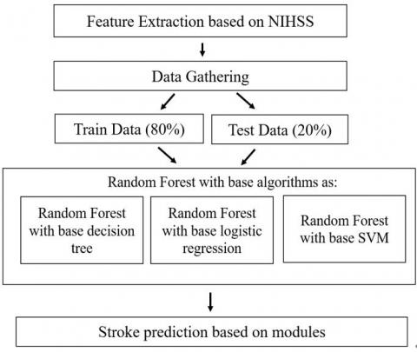

**Figure 3.** Model architecture

Figure 3 shows the proposed model can extract the features based on NIHSS for data gathering processes. After data gathering, the machine learning model works depending on the training data (80%) and testing data (20%). Both the training data and the test data are sent as inputs into the Random Forest algorithm which has the base classifiers namely base decision tree, base logistic regression and base SVM. The risk factor is thereby generated from the above model architecture. The detailed work flow of the proposed architecture is demonstrated in the following steps:

Step 1: Data Collection and pre-processing is explained in Figure 4(a).

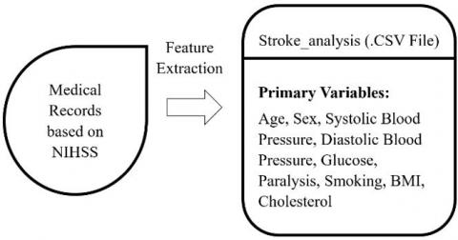

**Figure 4(a).** Feature extraction based on stroke scale

Step 2: Risk Formation is explained in Figure 4(b).

**Figure 4(b).** Risk formation based on best accuracy model

Step 3: Risk identification with different levels of stroke is represented in Figure 4(c).

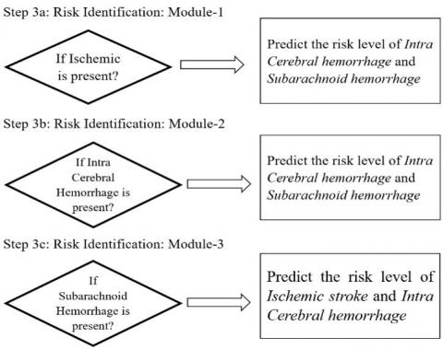

**Figure 4(c).** Stroke level prediction

**3.4 Proposed improvised random forest algorithm**

**Algorithm 3: Stroke Prediction (SPN)**

Step 1: If the model trained is ‘False’ then load the trained data and start training the model

Step 2: From the user data initialize the required data for the prediction.

Step 3: Assign ‘Y’ with a return value of the predicted object.

Step 4: if Y = = 0 then return “Low Risk”

          else if Y = = 1 then return “Moderate Risk”

          else if Y = = 2 then return “High Risk”

          else return “Severe Risk”

**Algorithm 4: Model Training**

Step 1: Load the trained data.

Step 2: From the user data initialize the trained model object.

Step 3: Return the model object.

**Algorithm 5: Stroke predictor (SPR)**

Step 1: Load the required new data.

Step 2: Process the new record with the existing model object

Step 3: From the new record, initialize the predicted object.

Step 4: Return the model object with predicted stroke levels.

**3.6 Performance evaluation metrics**

In the process of testing the Area Under Curve (AUC) and Receiver Operating Characteristics (ROC) is one of the standardized ways. It deals with the probability among the classifier of randomly picked positive sample to that of the randomly picked negative sample.







Accuracy (ACC) is evaluated to the number of all exact identifications separated to that of the sum of a number of the dataset.

Accuracy =  True Positive + True  Negative  True Positive + True  Negative + False Negative + False Positive

The Sensitivity is evaluated to the number of identifications of correct positive divisions to that of the total positives number.

Sensitivity = True Positives  True Positives + False Negative

The Specificity is determined by the total amount of correct negative identifications separated by the total negative numbers.

Specificity =*True Negative  True Negative + False Positives*

The False Positive Rate is determined by the FP / (FP+TN) evaluation. It is determined to the ratio of negative points that are wrongly taken as positive when compared to that of all the negative points of the data.

False Positive Rate = False Positive  True  Negative + False Positive

F1-Score determines how specific the classifier is and also how rigid it can be. The proportion of high precision and low recall draws out the most accurate possibilities, but it omits various examples that become complex while dividing. The mathematical expression is given by:

F1- Score = 2 ∗11 precision +1 recall

The Precision gives multiple positive outcomes when distinguished by a number of positive results identified by the classifiers.

Precision = True Positives  True Positives + False Positives

The retrieval-based approach tries to generate description for an image by selecting the most semantically similar sentences from sentence pool or directly copying sentences from other visually similar images. For example, Gong et al. utilize stacked auxiliary embedding method to generate image descriptions from millions of weakly annotated images. Ordonez find similar images in the Flickr database and return the descriptions of these retrieved images to query based on millions of images and their corresponding descriptions. Sun use semantic similarity and visual similarity scores to cluster similar terms and images together first and then retrieve the caption of target image from captions of similar images in the same cluster. Hodosh establish a ranking-based framework to treat sentence-based image description as the task of ranking a set of captions for each test image. These methods generate general and syntactically correct captions. However, it is difficult for them to generate image-specific and semantically correct captions.

Different from the mentioned two categories, novel caption generation approaches mainly use deep learning and machine learning to generate the new captions. A general implementation of this method is to analyze the visual content of the image first and then generate image captions from the visual content using a language model. For instance, Vinyals et al. use CNN as an encoder for image classification and LSTM as a decoder to generate sentence for the description. The main drawbacks of the work are the quick model overfitting, so they use the heavy and expensive GoogLeNet with 22 hidden layers and the absence of attention layer that significantly improved the description accuracy. Karpathy investigate the possibility of generating an image description in natural language. Their approach uses image datasets and their description in natural language and seeks an intermodal correspondence between words from the description and visual data. The first model aligns the fragments of sentences to the visual areas, then forms a single description by multimodal embedding. This description is treated as learning data for a second model of a recurrent neural network that learned to a generate caption. Xu et al. use a convolutional neural network to extract feature maps and LSTM to describe the input image, by processing already extracted feature maps. The limitation of this work is the using of obsolete and expensive Oxford VGGnet, where the quality of image classification is low in the modern CNN . Some researchers have put their attention on classification as Yu. who propose a SVM classification-based two-side cross-domain algorithm by inferring intrinsic user and item features (CTSIF-SVMs), a two-side cross-domain algorithm with expanding user and item features via the latent factor space of auxiliary domains (TSEUIF).

Stroke is the third leading cause of death and the principal cause of serious long-term disability in the United States. Accurate prediction of stroke is highly valuable for early intervention and treatment. In this study, we compare the Cox proportional hazards model with a machine learning approach for stroke prediction on the Cardiovascular Health Study (CHS) dataset. Specifically, we consider the common problems of data imputation, feature selection, and

prediction in medical datasets. We propose a novel automatic feature selection algorithm that selects robust features based on our proposed heuristic: conservative mean. Combined with Support Vector Machines (SVMs), our proposed feature selection algorithm achieves a greater area under the ROC curve (AUC) as compared to the Cox proportional hazards model and L1

regularized Cox model. Furthermore, we present a margin-based censored regression algorithm that combines the concept of margin-based classifiers with censored regression to achieve a better concordance index than the Cox model. Overall, our approach outperforms the current state-of-the-art in both metrics of AUC and concordance index. In addition, our work has also identified potential risk factors that have not been discovered by traditional approaches. Our

method can be applied to clinical prediction of other diseases, where missing data are common and risk factors are not well understood.

**2.3 PROPOSED SYSTEM**

In this project, we’ll be going through a five-step process for creating our project:

1. Collecting data from “Stroke Prediction Dataset”.

2. Prepare data for training and testing using the Seaborn and Plotly libraries.

3. Comparing different models on the basis of accuracy.

4. Optimize the model by applying K-Fold Cross-Validation and Hyper Parameter optimization.

5. Getting input from the user and finally predicting the chances of stroke based on risk factors.

**CHAPTER - 3**

**PROBLEM DESCRIPTION AND SPECIFICATION**

**3.1 PROBLEM DESCRIPTION**

To compare various machine learning algorithms based on their accuracy of stroke prediction and build a system for the same.

**3.2 SPECIFICATION**

Stroke prediction is a task that involves machine learning concepts to recognize the possible factors contributing to the conditions developing strokes and to help prevent them using analytics to analyses the possible scenarios to stop or prevent it.

The aim of Stroke prediction is to apply various machine learning algorithms on the “Stroke Prediction Dataset and evaluate the models based on their accuracy. Also, create an interface where a user can provide his medical details and the prediction model will provide the chances of the stroke to him. Moreover, a comparison between various machine learning algorithms helps us in determining the most suitable algorithm for the prediction model. This prediction model can aid in clinical decision making and help patients to have an improved and reliable stroke risk prediction. In future, we can use more risk factors to train our model and enhance the accuracy of the model. The web interface will be friendly and also, we can provide valuable suggestions to users as per their stroke risk.



Figure 1: Process Flow Diagram



**3.3 REQUIREMENTS**

**3.3.1 SOFTWARE REQUIREMENTS**

* Python Version 3.6+
* IDE: JupyterLab or PyCharm
* Frameworks: -
  + Flask
  + Bootstrap
* Python Libraries:-
  + Scikit-learn
  + Seaborn
  + Numpy: 1.18.5
  + Pandas: 1.1.14

**3.3.2 HARDWARE REQUIREMENTS**

* Processor:- Intel i3+ or AMD A6+
* RAM:- 2GB/+
* Hard Disk Space:- 2GB

**3.3.3 OTHER REQUIREMENTS**

* Stroke Prediction Dataset
* For training the model - Kaggle Notebook/Google Colab/JupyterLab should be preferred (Recommended)

**CHAPTER - 4**

**SYSTEM DESIGN**

**4.1 INTRODUCTION**

According to World Health Organization (WHO) stroke is the 2nd leading cause of death globally, responsible for approximately 11% of the total deaths. Through this project we will compare various machine learning algorithms based on their accuracy of stroke prediction and build the system for the same.

The model will consist of a front-end GUI for collecting data. Flask file to connect the model to backend model. For the backend model we will be comparing 10 different ML algorithms for their accuracy. Select the best one and perform K-fold Cross validation and hyper-parameter optimization on it.

**4.1.1. Data Sources**

We had selected “Stroke-prediction dataset” obtained from Kaggle as our dataset. This dataset contains of 5110 records having 12 attributes (id, age, gender, hypertension, heart disease, marital status, residence type, work type, average glucose level, BMI, smoking status and stroke occurrence). The below image provides the info about the dataset.

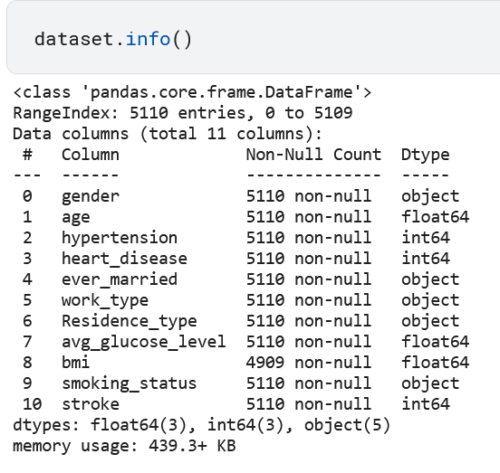

Figure: Output showing the dataset information

**4.1.2. MACHINE LEARNING ALGORITHMS USED IN THE PROJECT**

In this project we are going to train our dataset on 10 different machine learning algorithms and based on their performance we will select the best model and further use it in building the stroke prediction system. The 10 machine learning algorithms used in this project are: -

1. Gaussian Naive Bayes
2. Bernoulli naïve Bayes
3. Logistic Regression
4. Support Vector Machines
5. Random Forest
6. Decision Tree classifier
7. K-Nearest Neighbor
8. Gradient Boosting
9. Stochastic Gradient Descent
10. Neural nets

**4.1.3. MODEL PARAMETERS**

A model parameter is a configuration variable that is internal to the model and whose value can be estimated from data. The various parameters we computed for the machine learning algorithms we covered are: -

* 1. Accuracy- The accuracy of a machine learning classification algorithm is one way to measure how often the algorithm classifies a data point correctly. Accuracy is the number of correctly predicted data points out of all the data points.
  2. Precision- Precision (also called positive predictive value) is the fraction of relevant instances among the retrieved instances.

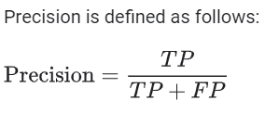

Where, TP is True positives

FP is False Negatives

* 1. Recall- Recall (also known as sensitivity) is the fraction of relevant instances that were retrieved.

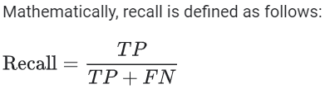

* 1. F1 Score- In statistical analysis of binary classification, the F-score or F-measure is a measure of a test's accuracy. It is calculated from the precision and recall of the test.

The formula for F1 Score is-

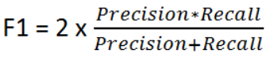

* 1. Specificity- Specificity (True Negative rate) measures the proportion of negatives that are correctly identified (i.e., the proportion of those who do not have the condition (unaffected) who are correctly identified as not having the condition).

Mathematically specificity is given by-



**4.2 ARCHITECTURE DIAGRAM**

The stroke predicition system using machine learning predicts the risk of stroke to the user based on the various symptom information the user gives, such as age, gender, marital status, hypertension, prior heart disease and smoking status. The architecture of the stroke risk prediction using machine learning consists of the dataset through which we will compare the symptoms of the user. Model is trained using the dataset. The classification algorithms process the data and predicts the risk of stroke. The diagram below explains about the system in perception of overview of the system.

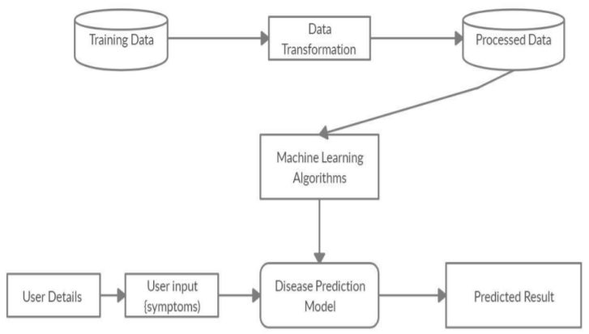

Figure 2: Architecture of the Stroke prediction model

**4.3 UNIFIED MODELING LANGUAGE(UML)**

**4.3.1 USE CASE DIAGRAM**

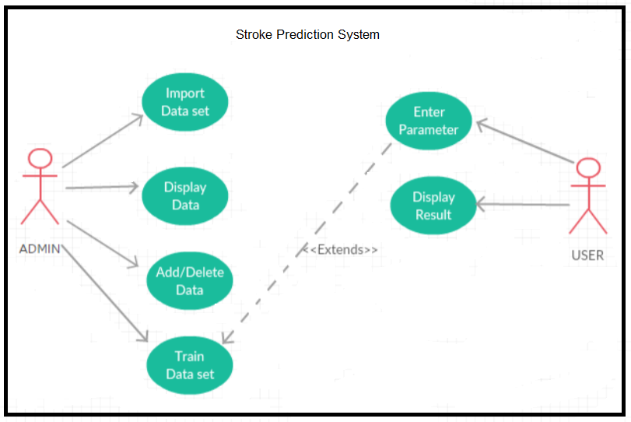

Figure 4: Use Case Diagram for stroke prediction system

The Use Case diagram of the project stroke prediction using machine learning consist of all the various aspects a normal use case diagram requires. This use case diagram shows how from starting the model flows from one step to another, the user fills all the medical details as asked in the form, the system compares with the prediction model and if true is predicts the appropriate results otherwise it shows the details where the user if gone wrong while entering the. Here the use case diagram of all the entities is linked to each other where the user gets started with the system.

**4.3.2 DATA FLOW DIAGRAM**

The entire working or the flow of the data can be divided into three groups for better understanding. They are- 1. DFD-L0 2. DFD-L1 3. DFD-L2

**4.3.2.1 Data Flow Diagram Level 0**

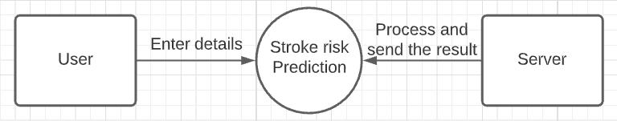

Figure 5: DFD level 0

This is the initial idea for the flow of the data. The data has to be flown from user to server and from server to the user for the prediction of the stroke risk by entering details and sending the data. Communication is done between user and the server.

**4.3.2.2 Data Flow Diagram Level 1**

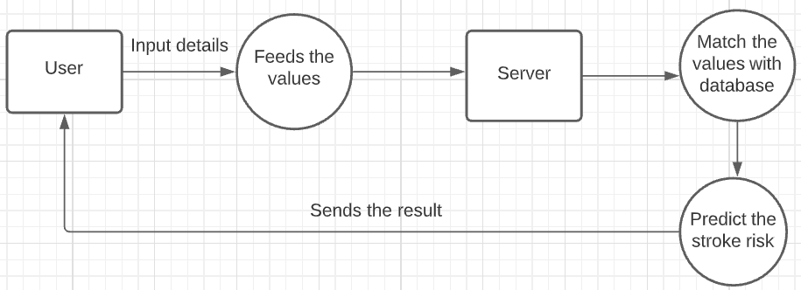

Figure 6: DFD level 1

This is the process or the idea where the data has been used to predict the disease by following steps like Feed the values (entering the medical parameters), Server (to store them), match the values (Finding probability) and finally predict the risk of stroke (Final result).

**4.3.2.3 Data Flow Diagram Level 2**

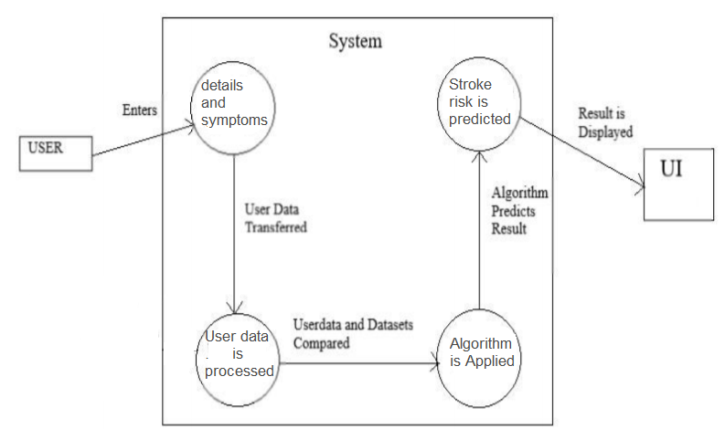

Figure 7: DFD level 2

The level 2 dataflow diagram of the project stroke prediction using machine learning consists of all the various aspects a normal flow diagram requires. This dataflow diagram shows how from starting the model flows from one step to another, like the user fills all the required form information regarding his medical information as asked in the form. The user data is processed and the trained model predicts the risk of stroke. The result is finally displayed in the webpage.

**4.4 SEQUENCE DIAGRAM**

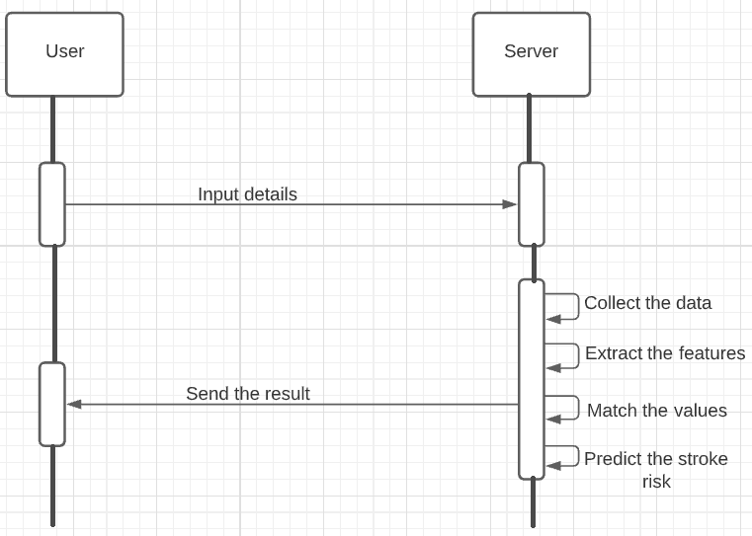

Figure 8: Sequence Diagram of the system

Sequence diagrams describe interactions among classes in terms of an exchange of messages over time. It shows how different events take place.

**4.5 FLOW CHART FOR CAPTION GENERATION PROCESS**

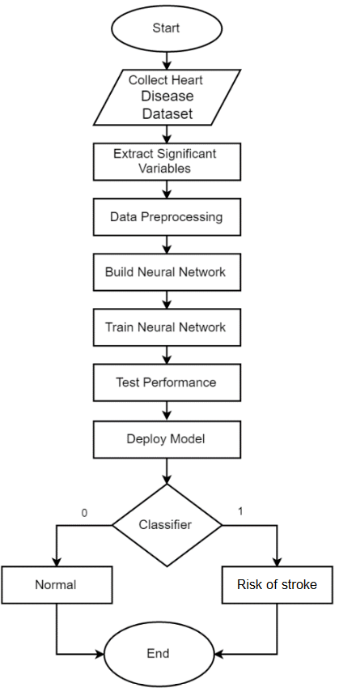

Figure 9: Flow chart for the stroke prediction system

Figure 9 shows the overall flow of work in the stroke prediction system. Initially heart disease data is collected. After data preprocessing, significant variables are extracted. Null values are also handled. We build the neural network using various machine learning algorithm. Train and test the model. The model with the highest accuracy is selected and we build the system using the same. The classifier predicts the risk of stroke and displays the output in the webpage.

**CHAPTER - 5**

**IMPLEMENTATION AND RESULT**

**5.1 OVERVIEW**

In this section, we are going to cover all the steps we have taken while implementing the program. The whole program consists of different sections giving a brief about the program implementation and their respective outputs.

**5.2 IMPORTING THE NECESSARY LIBRARIES AND DATASET**

…………Write a brief

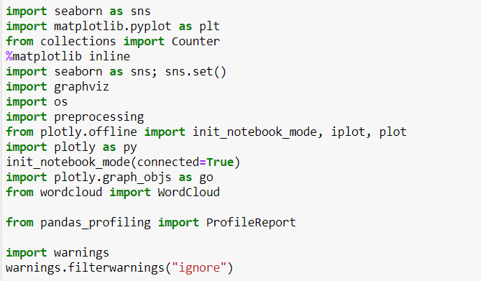

Figure: Code snippet showing the import of libraries used in the project



Figure: Code snippet to read the dataset

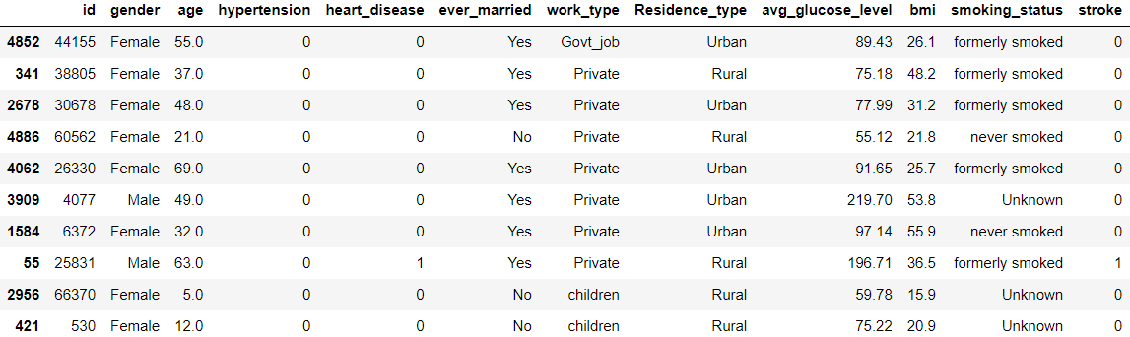

Figure: 10 Sample data from the dataset

We’ll drop the ‘id’ column as it may cause unwanted correlation.

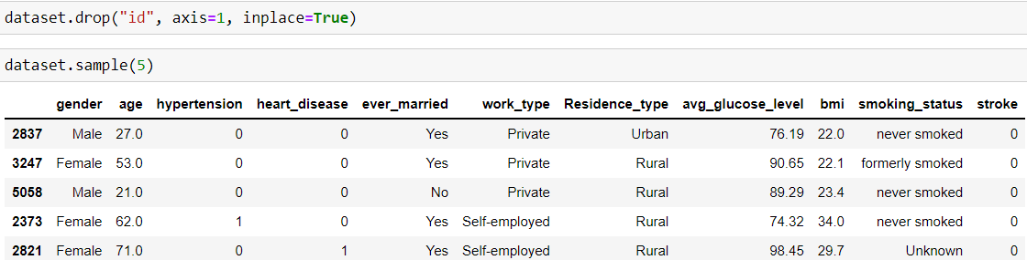

Figure- Code snippet and resultant table after dropping the id column

**5.3 BASIC DATA ANALYSIS**

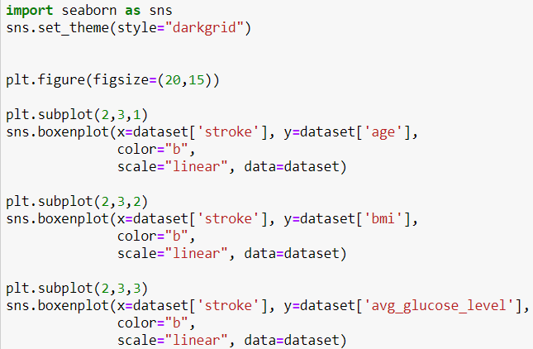

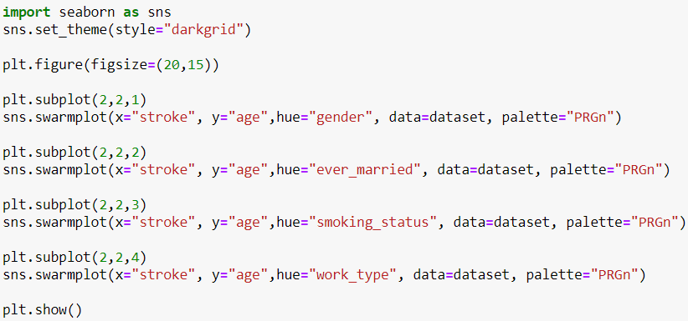

Figure: Code snippet to visualize the dataset

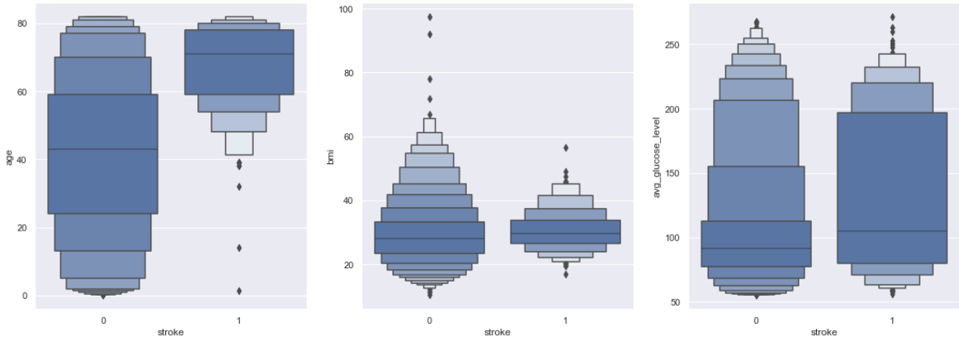

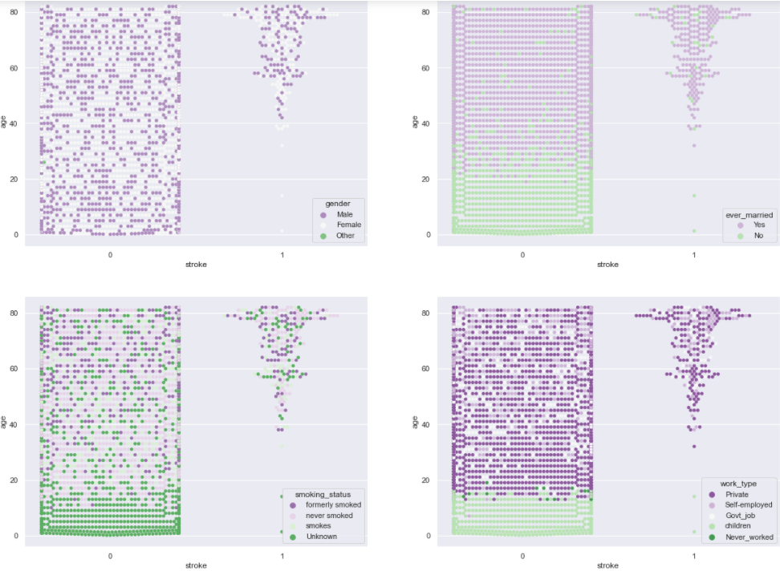

Figure 13: Visual representation of dataset

**5.4 PANDAS PROFILING**

Pandas profiling is a useful library that generates interactive reports about the data. With using this library, we can see types of data, distribution of data and various statistical information. This tool has many features for data preparing. Pandas Profiling includes graphics about specific feature and correlation maps too.

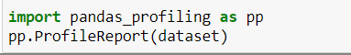

Figure : Code snippet showing pandas profiling

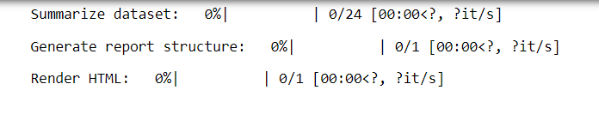

Figure: Pandas profile report

**5.5 CORRELATION**

Correlation explains how one or more variables are related to each other. These variables can be input data features which have been used to forecast our target variable.

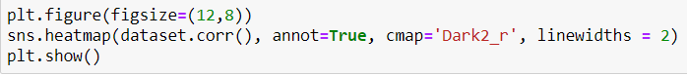

Figure 20: Code snippet to show correlation

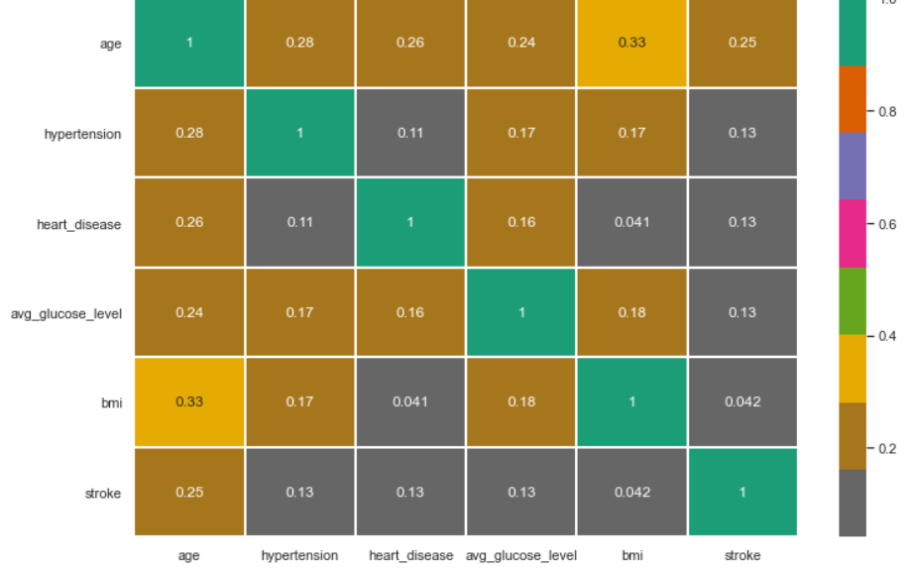

Figure 21: Sample output showing the heatmap of correlation



Figure 22: Code snippet for…..

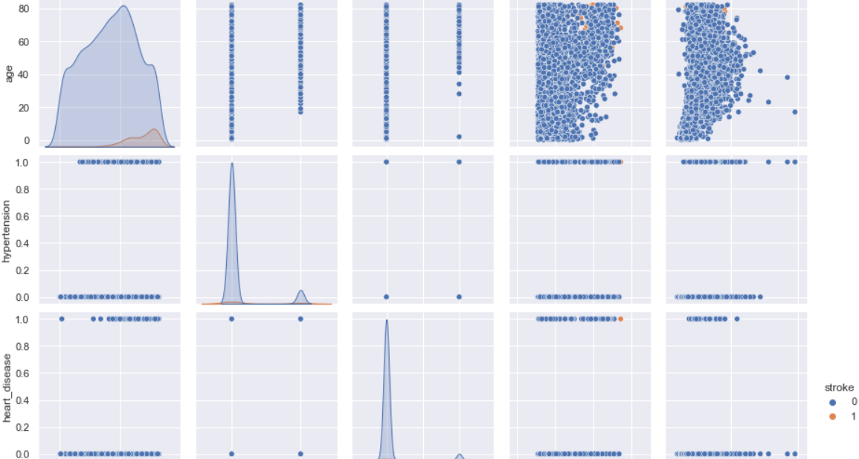

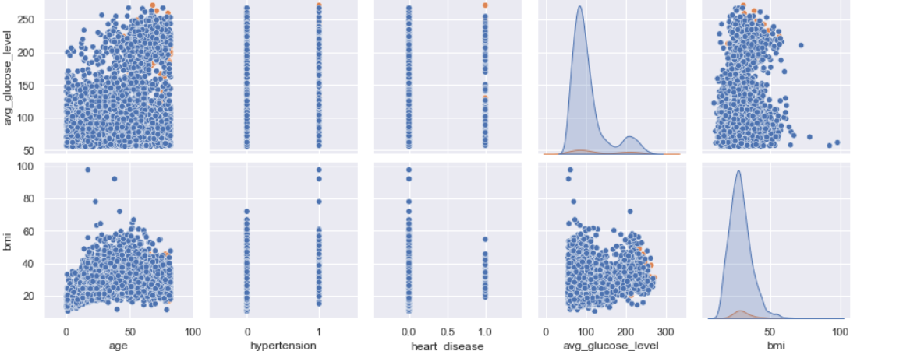

Figure 23: Sample output showing the…..

**5.6 ANAMOLY DETECTION**

Anomaly is one that differs / deviates significantly from other observations in the same sample. An anomaly detection pattern produces two different results. The first is a categorical tag for whether the observation is abnormal or not; the second is a score or trust value. Score carries more information than the label. Because it also tells us how abnormal the observation is. The tag just tells you if it's abnormal. While labeling is more common in supervised methods, the score is more common in unsupervised and semi supervised methods.

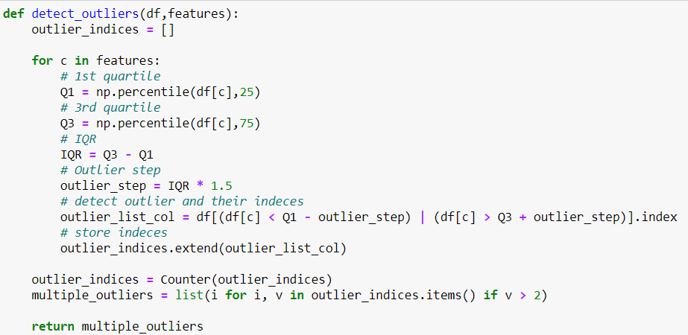

Figure 24: Code snippet showing the detection of outliers

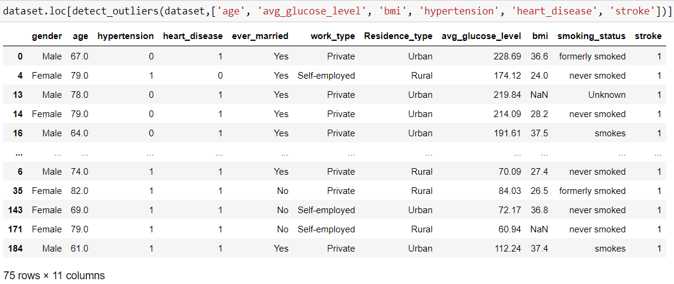

Figure 25: Output showing the detection of outliers

dataset = dataset.drop(detect_outliers(dataset,['age', 'avg_glucose_level', 'bmi', 'hypertension', 'heart_disease', 'stroke']),axis = 0).reset_index(drop = True)

Figure 26: Code snippet to drop the dataset containing outliers

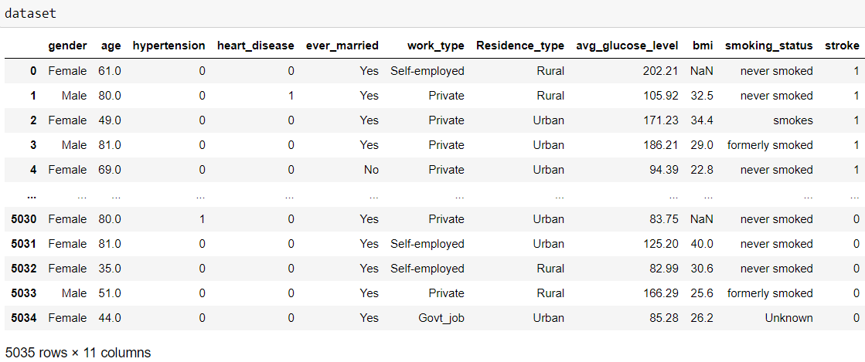

Figure 27: Resultant table after anomaly detection and rectification

**5.7 HANDLING MISSING VALUES**

We have 201 null values in total. After anomaly detection it reduced to 193.

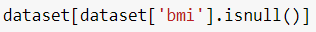

Figure 29: Code snippet to check for missing bmi values.

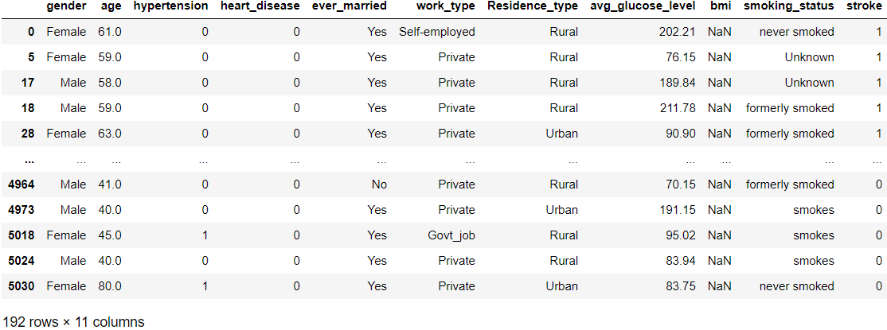

Figure 30: Output showing the rows where BMI value is null.

How to handle missing values?

We selected difference of BMI will be between gender

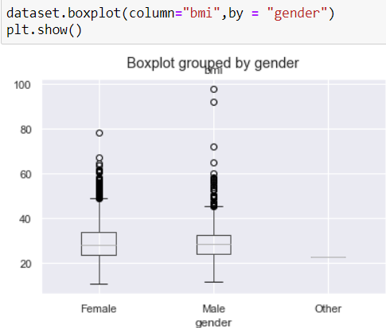

Figure 31: Output showing the boxplot grouped by gender

We get different BMI averages for women and men, although not very large. So we assigned the total BMI mean as there are very few examples for the Others gender.

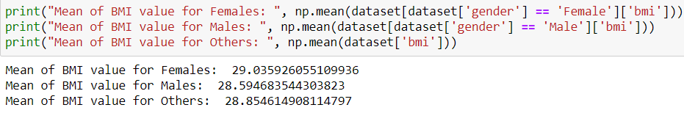

Figure: Code snippet and output showing the mean BMI based on gender

We fill the BMI field with null values to 0.

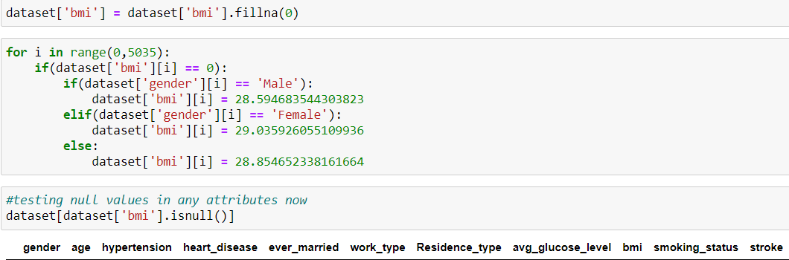

Figure 32: Code snippet and output showing that none of the field contains null or missing values

**5.8 ENCODING**

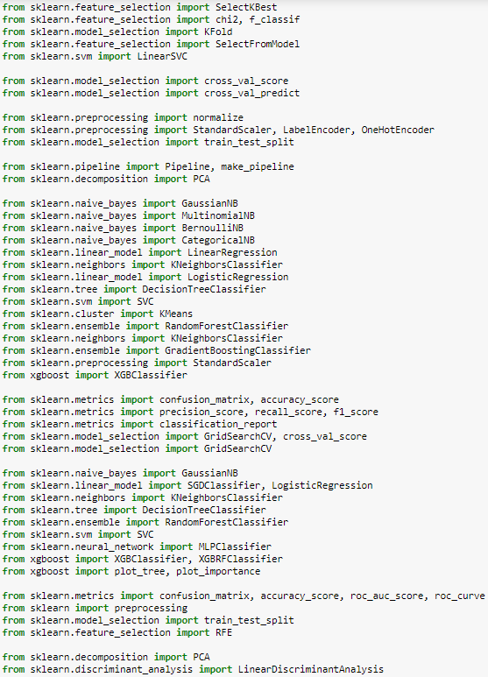

Figure 34: Code snippet for encoding

First, we will handle categorial values.

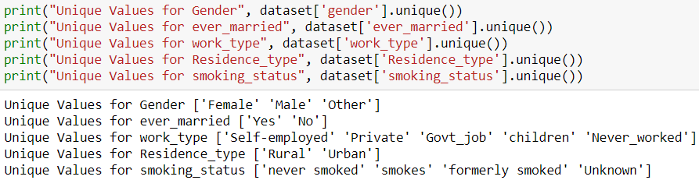

Figure 35: Code snippet and output for handling categorial values

**5.8.1 LABEL ENCODING**

Label Encoding is an encoding technique for handling categorical variables. In this technique, each data is assigned a unique integer.

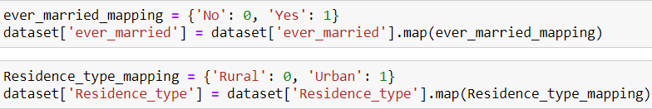

Figure 36: Code snippet to implement label encoding

**5.8.2 ONE HOT ENCODING**

One Hot Encoding is the binary representation of categorical variables. This process requires categorical values to be mapped to integer values first. Next, each integer value is represented as a binary vector with all values zero except the integer index marked with 1.

One Hot Encoding makes the representation of categorical data more expressive and easier. Many machine learning algorithms cannot work directly with categorical data, so categories must be converted to numbers. This operation is required for input and output variables that are categorical.

Here, we converted categorical data to the binary values. This operation increases the accuracy.

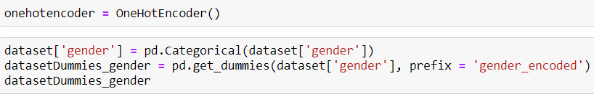





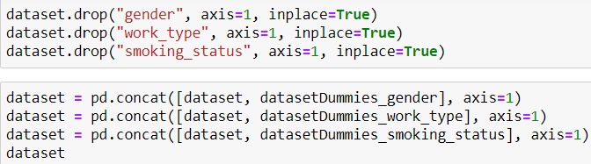

Figure: Code snippet for implementing one hot encoding

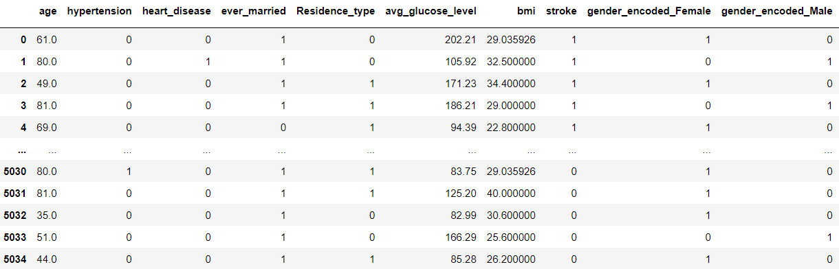

Figure: Sample output showing the table doesn’t contain categorial variables.

Dataset is now ready for implementing machine learning algorithms.

**5.9 TRAINING AND TESTING OF DATA**

Here we split the dataset in the ratio……

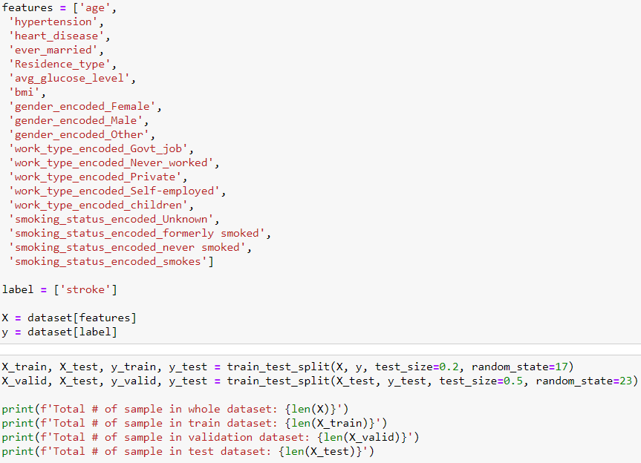

Figure 37: Code snippet showing the dataset is split for the purpose of training, testing and validation.

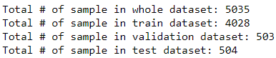

Figure 38: Output showing the amount of data used for training, testing and validation

**5.9.2 STANDARDIZATION**

Standardization is a method in which the mean value is 0 and the standard deviation is 1, and the distribution approaches the normal. The formula is as follows, we subtract the average value from the value we have, then divide it by the variance value.

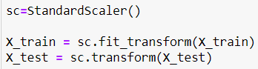

Figure: Code snippet to implement Standardization

**5.9.3 SAVING THE SCALER OBJECT**

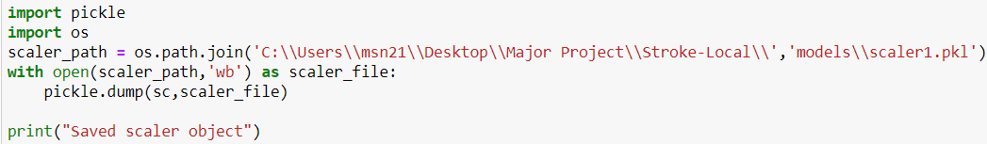

Figure: Code snippet for saving the scaler object

**5.10 COMPUTING TRAINING SCORE OF MODELS**

The following are the ML algorithms that will apply to dataset. Results will contain train-validation-test scores, confusion matrix, statistical information and classification reports for each algorithm.

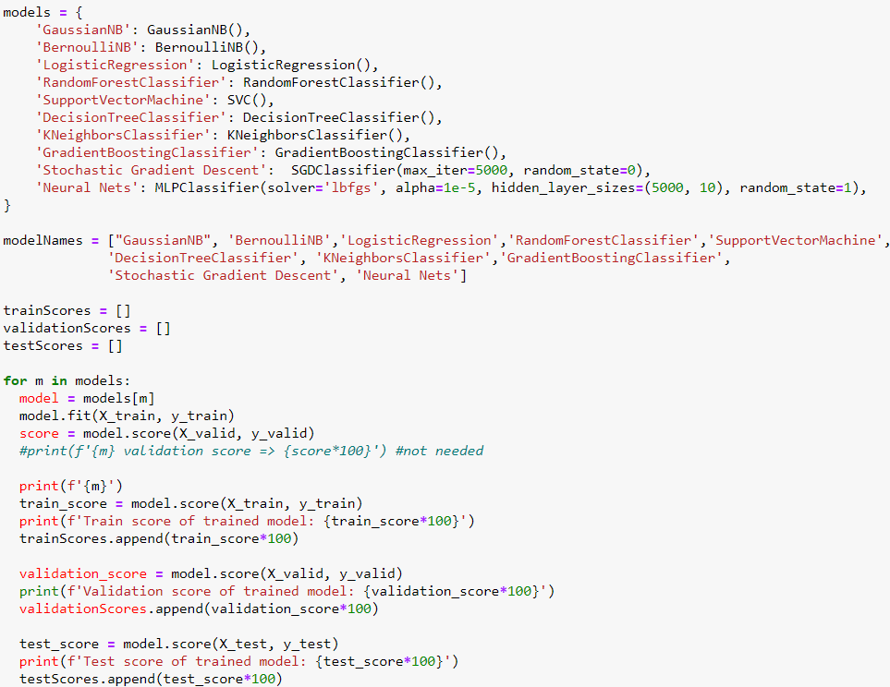

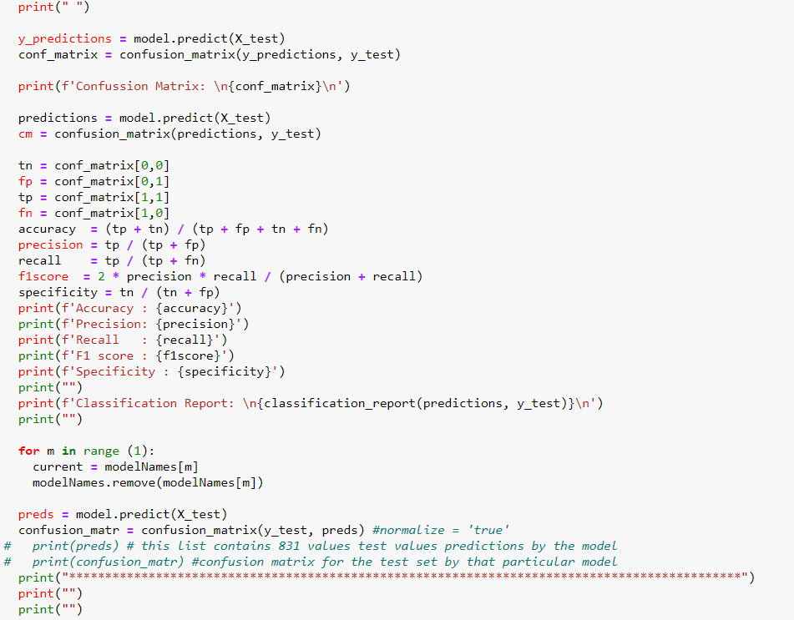

Figure: Code snippet for computing accuracy, precision, recall, F1 score, specificity and confusion matrix of various ML algorithms

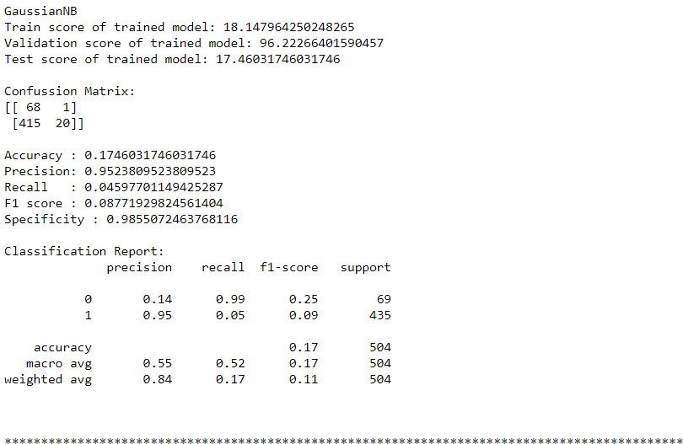

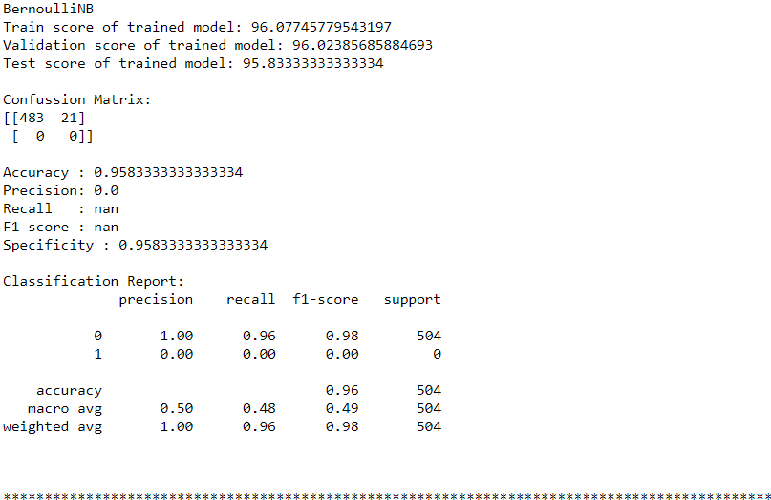

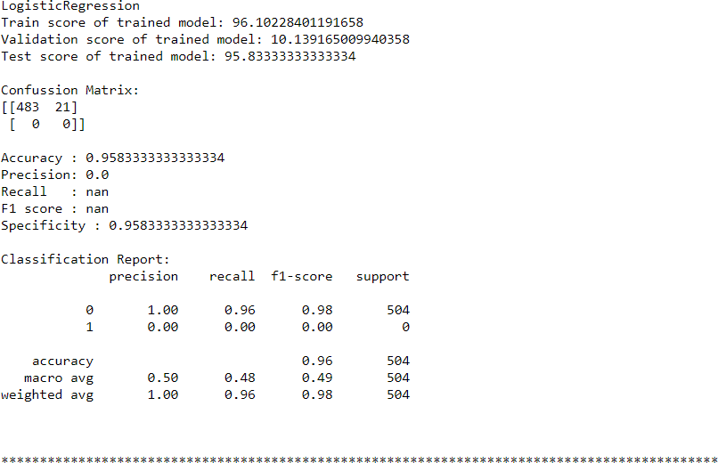

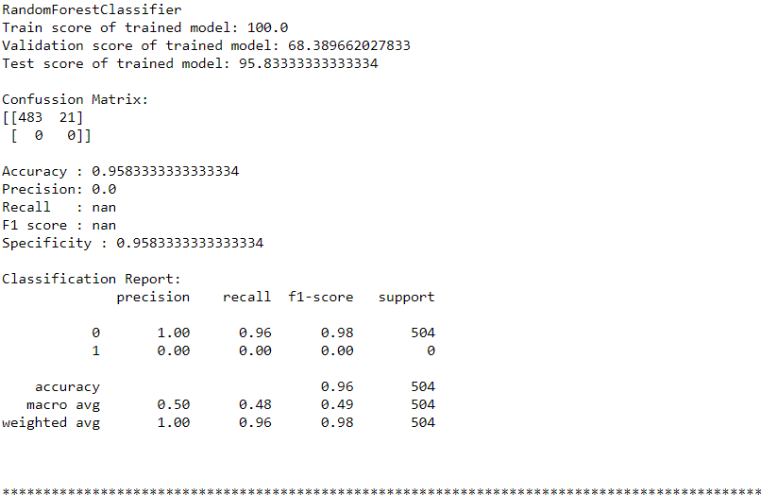

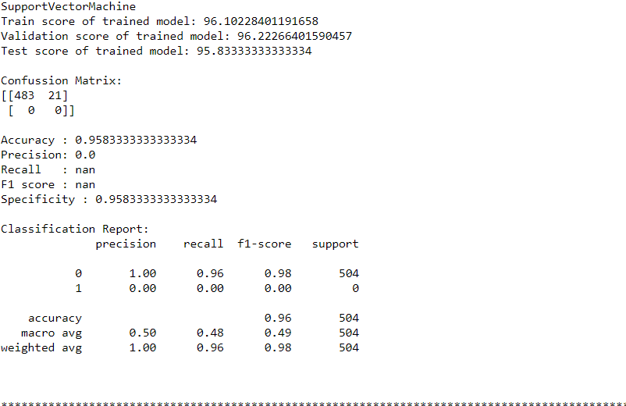

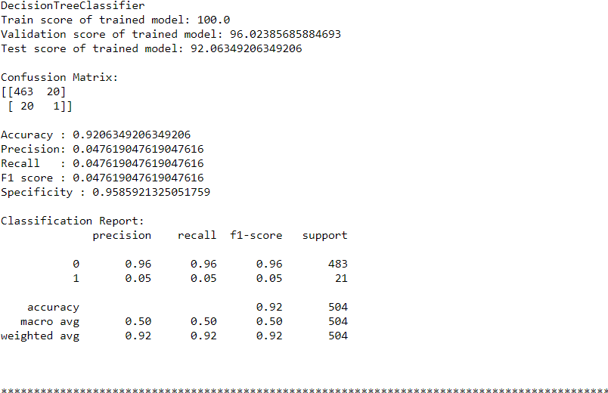

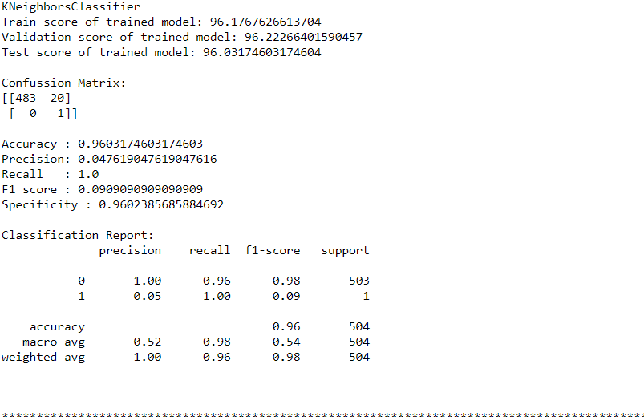

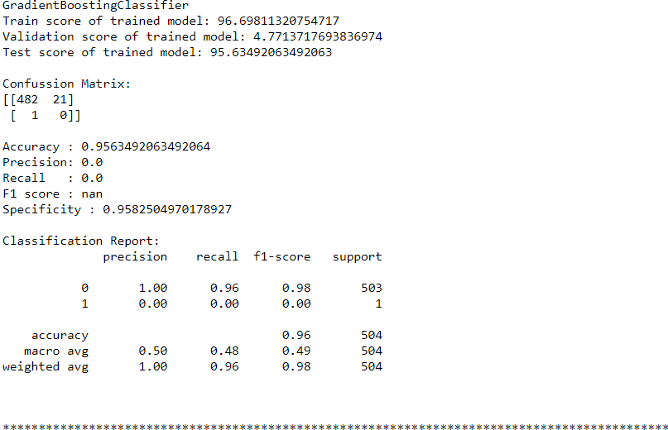

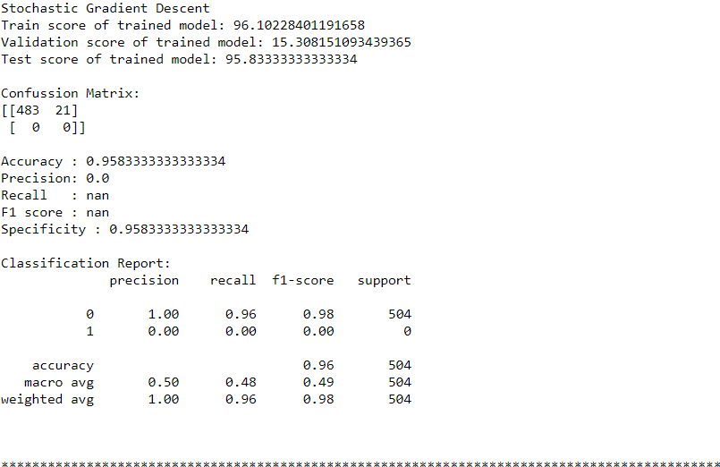

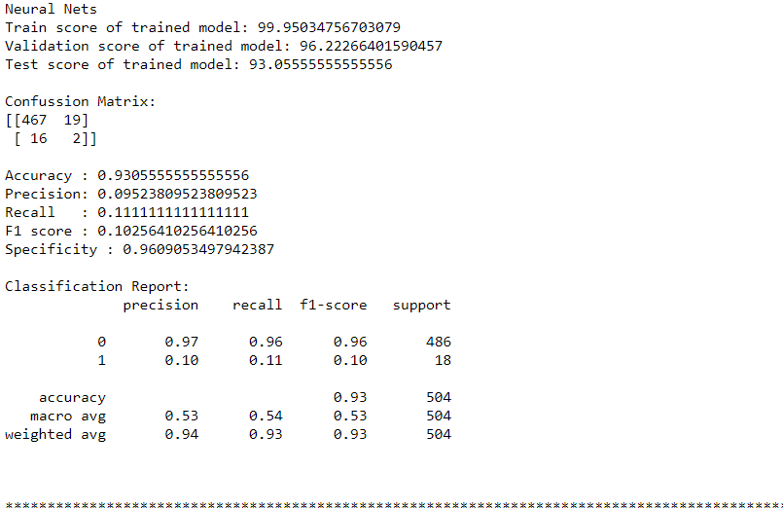

Figure: Output containing accuracy, precision, recall, F1 score, specificity and confusion matrix of various ML algorithms

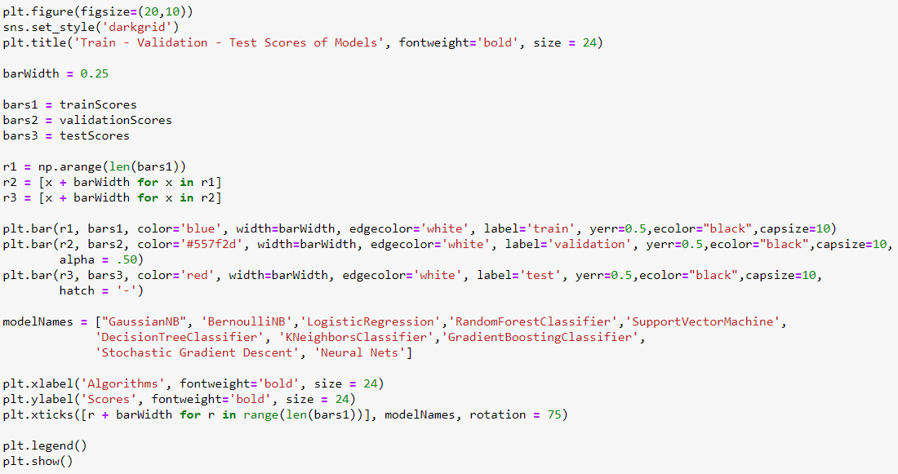

Figure: Code snippet to graphically visualize the train-validation-test score of models

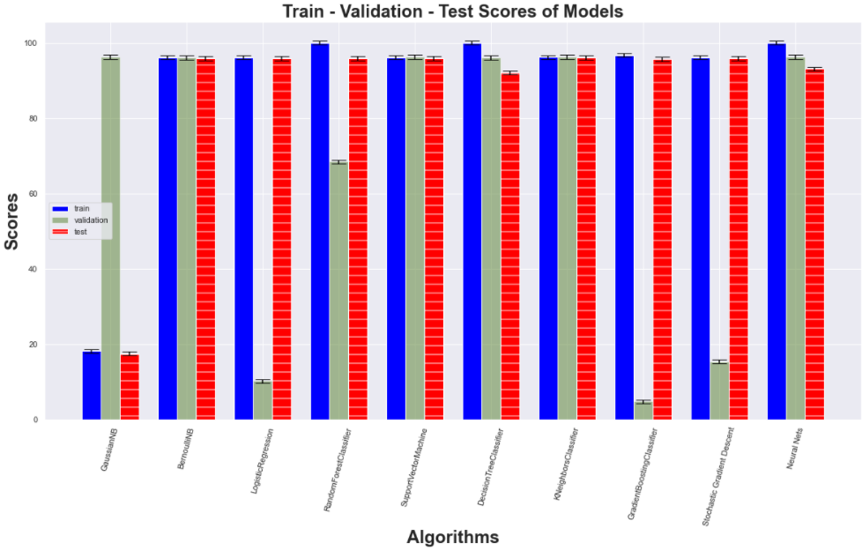

Figure: Graphical output of train-validation- test score of models

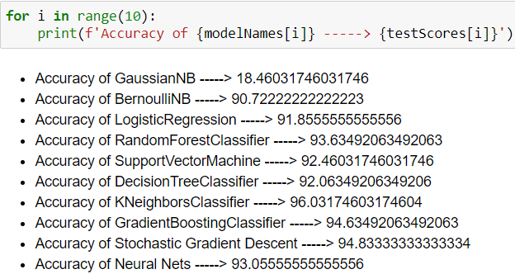

Figure: Code snippet and output showing the accuracy of each model

We observed that K Neighbors Classifier has the highest accuracy of 96.03174603174604

**5.11 MODEL SELECTION AND OPTIMIZATION**

We evaluated these models according to their accuracies, precision, recall, F1 score, specificity and created their confusion matrix. Selecting model based on parameter accuracy, Best algorithm is KNN with highest accuracy of 96.03%. Now we will make k-Fold Cross Validation and Hyper-Parameter Optimization for KNN algorithm**.**

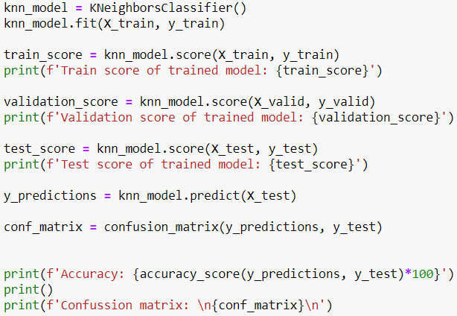

Figure: Code snippet for model selection and training

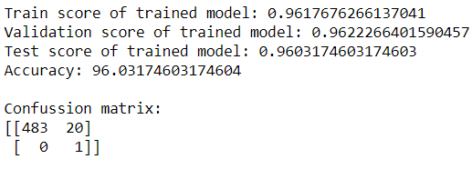

Figure: K Neighbors Classifier score along with accuracy and confusion matrix

**5.11.1 SAVING THE BEST MODEL**

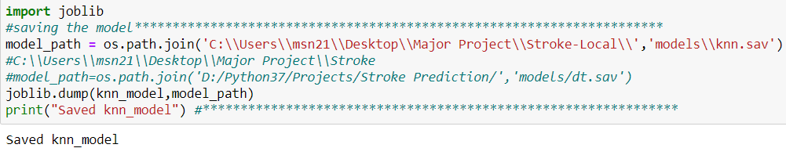

Figure: Code snippet for saving the KNN Model

**5.11.2 MODEL OPTIMIZATION: K-FOLD CROSS VALIDATION**

Cross Validation will enable us to see whether we are facing an overfitting problem and also to see the quality of our model. Thus, it will enable us to test the performance of our model before encountering high error rates in the test data set that we have not seen yet. It is a method that is frequently used because it is easy to apply.

**cv = 10 means k = 10 for KNN.**

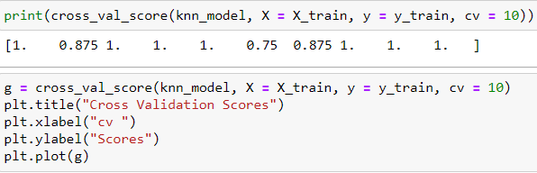

Figure: Code snippet to implement K-Fold Cross validation

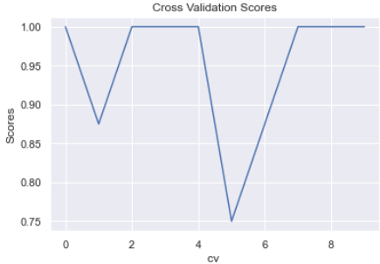

Figure: Graphical output after implementing K-Fold Cross validation

MEAN ABSOLUTE ERROR

In statistics, mean absolute error (MAE) is a measure of errors between paired observations expressing the same phenomenon. Examples of Y versus X include comparisons of predicted versus observed, subsequent time versus initial time, and one technique of measurement versus an alternative technique of measurement.



Figure: Code snippet to compute MAE after applying K-Fold Cross Validation

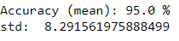

Figure: Output showing MAE and std

**5.11.3 MODEL OPTIMIZATION: HYPERPARAMETER OPTIMIZATION**

Unlike parameters, hyperparameters are not learned during training the model. They are determined by the data scientist before the modeling phase. For example, KNN algorithm, which is one of the non-parametric classification algorithms, makes classification by looking at the nearest k neighbors to the desired value. Here, the k number (n_neighbors:) and the distance metric (metric:) to be used are the hyperparameters that should be specified by the data scientist before the modeling, which increases the performance of the model.

**Hyperparameter optimization** is the process of finding the most suitable hyperparameter combination according to the success metric specified for a machine learning algorithm.

Given that there are dozens of hyperparameters for a machine learning algorithm and dozens of values these hyperparameters can take, it's clear how difficult it will be to try all combinations one by one and pick the best combination. For this reason, different methods have been developed for hyperparameter optimization. GridSearcCV and RandomizedSearchCV are among these methods.

### **GridSearchCV:** For the hyperparameters and their values that are desired to be tested in the model, a separate model is established with all combinations and the most successful hyperparameter set is determined according to the specified metric.

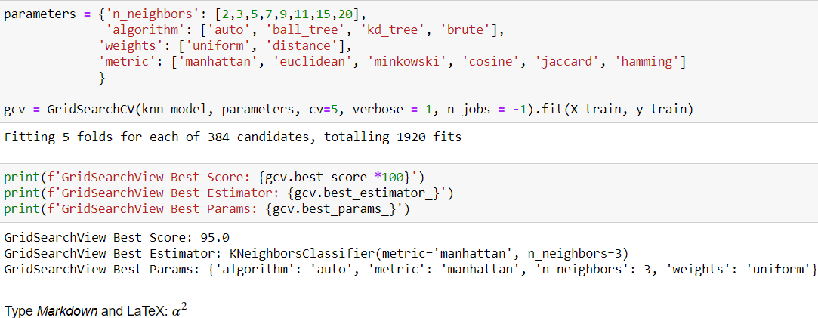

Figure: Code snippet and sample output after applying GridSearchCV

### **RandomizedSearchCV:** A set of hyperparameters is randomly selected and tested by cross-validation and the model set up. These steps continue until the specified calculation time limit or the number of iterations is reached.

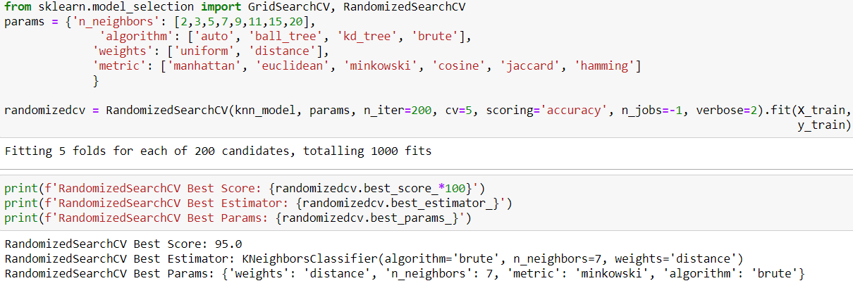

Figure: Code snippet and sample output after applying RandomizedSearchCV

5.11.4 BEST FEATURE SELECTION

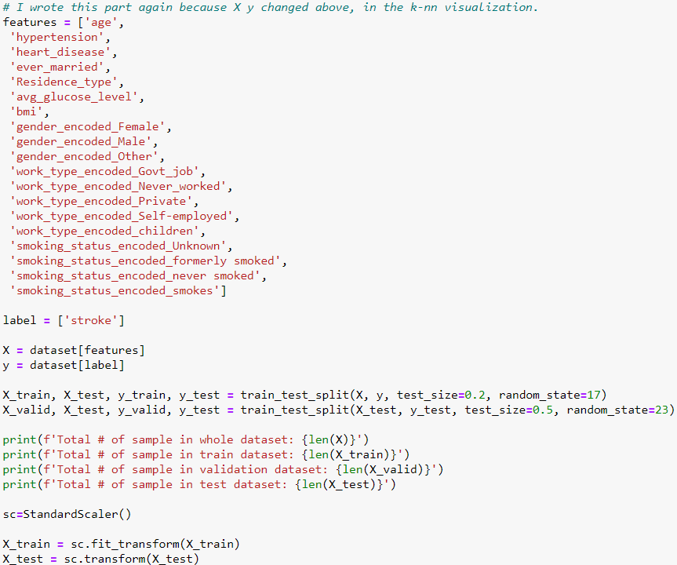

Figure: Code snippet for best feature selections

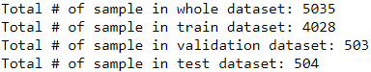

Figure: Sample output

**5.12 WEB PAGE DEVELOPMENT**

For the purpose of providing interfaces to users, we needed to develop a platform. Thus we chose web development for this. In this project, we created a web app using Python and it’s web framework flask, which reduces development time and allows us to build faster and smarter. For the Frontend, we have created a simple webpage which consist of a form which is to be filled by the user.

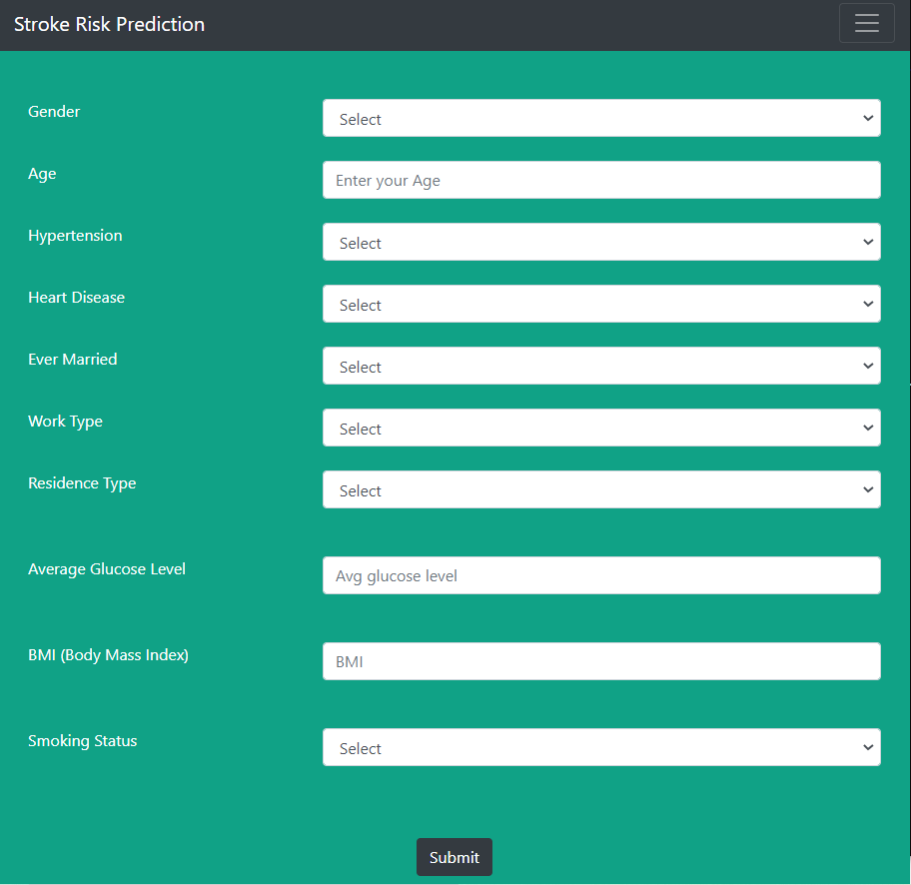

Figure: Layout of the webpage (User form)

**5.13 CONNECTING MODEL WITH FRONTEND AND PYTHON CODE**

The backend and frontend both work together to serve a single goal. It’s pretty helpful to keep it in mind at all times. They are made, so a user can access them.

WORKING OF WEBSITE

The user points their browser to one of your website’s URLs and waits for the browser to render the page. The user sees a useful and usable page. The user interacts with the page.

Thus till now, our website was working as static. In order to connect it to our working python code, we used flask i.e, micro-framework of python. In this, we created several routes using route decorator and thus it helped us in hosting it to a local server - http://localhost:7000/

**5.14 PREDICTING THE RISK OF STROKE**

The index() function is decorated with @app.route so that it is invoked when the browser sends a POST request. Using the request module of Flask it creates an object of the file and saves it in local storage. At the same time, it sends that filled parameters to python code by calling its function which in response returns the output string, which is then displayed on the webpage.

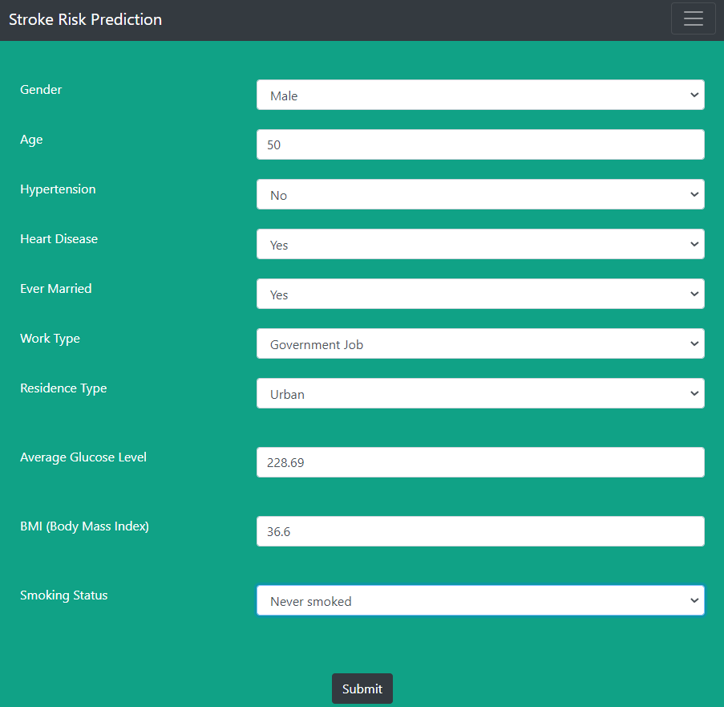

Figure 40: Sample input data filled in the Form

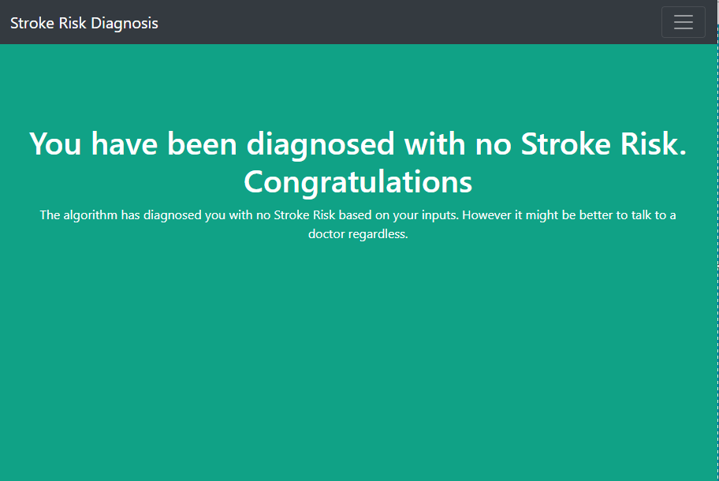

Figure 41: Sample results displayed at the Web Platform when using the model for prediction

Figure shows the front page of the Web App as visible to the user. Here he/she can fill the form based on their medical history and click on the submit button. The model functions in the background and provide the stroke risk which is shown on the Web App as shown in figure. Flask library is used to fetch the result predicted by the model and display it on the Web Page.

**CHAPTER - 6**

**CONCLUSIONS AND FUTURE SCOPE**

**6.1 CONCLUSIONS**

Through this project, we were able to build a system that can be used by user from the timing, location of his/her choice and check for chances of stroke to him. We compared 10 different machine learning classifiers based on accuracy on our dataset, used the best one and performed k-fold validation and hyper-parameter optimization on it too. We were able to understand the different and working of different classifiers and reason behind there particular behavior on our dataset. We are ultimately able to achieve our objective of learning about various machine learning classifier, comparing them and using the best one to build a system which can be used by anyone from anywhere to test the chances of stroke to him/her.

**6.2 FUTURE SCOPE**

There is a huge feature approach for this model some of which are enlisted below:

* The model is currently trained and tested for accuracy on a small dataset of approx. 5k records. We believe training it on any other dataset, which is bigger in size would enhance or prediction capability even more.
* Right now, the user is only asked for details in the form. We plan to enhance the web platform to display more information and statistics about the stroke.
* An android app for same purpose can be really useful and handy, we will this could be a potential future scope.
* Right now, the model uses 10 parameters for predicting the chances of stroke, adding more crucial parameters which play role in stroke and its prediction could be a really nice enhancement to the model.
* Adding more information about what stroke actually is, it causes, symptoms and other related and relevant information on the web page is also a nice and useful scope.
* Adding functionality to fetch all health record data and then use patient history for predicting chances of stroke could be a super huge enhancement.

**CHAPTER - 7**

**REFERENCES**

**Datasets:**

[1] “Dataset: Cardiovascular health study (CHS).” https://biolincc.nhlbi.nih.gov/studies/chs/. Accessed: 2016-05-8.

[2] "Stroke Prediction Dataset - (fedesoriano)." https://www.kaggle.com/fedesoriano/stroke-prediction-dataset

**Model Classifiers: -**

[3] Scikit-learn Supervised Models - https://scikit-learn.org/stable/supervised_learning.html

[4] GaussianNB - UPDATING FORMULAE AND A PAIR-WISE ALGORITHM FOR COMPUTING SAMPLE VARIANCES - Tony F.Chan, Gene H. Golub, Randall J. LeVeque:-Dept. Of CS, Standord NOV,1979 {<https://scikit-learn.org/stable/modules/generated/sklearn.naive_bayes.GaussianNB.html> }

[5] MultinomialNB - {<https://nlp.stanford.edu/IR-book/html/htmledition/naive-bayes-text-classification-1.html> } {<https://scikit-learn.org/stable/modules/generated/sklearn.naive_bayes.MultinomialNB.html> }

[6] BernoulliNB - {<https://nlp.stanford.edu/IR-book/html/htmledition/the-bernoulli-model-1.html> } {<https://scikit-learn.org/stable/modules/generated/sklearn.naive_bayes.BernoulliNB.html> }

[7] CategoricalNB - {<https://scikit-learn.org/stable/modules/generated/sklearn.naive_bayes.CategoricalNB.html> }

[8] LinearRegression - {<https://scikit-learn.org/stable/modules/generated/sklearn.linear_model.LinearRegression.html> }

[9] KNeighborsClassifier - {<https://en.wikipedia.org/wiki/K-nearest_neighbors_algorithm> } {<https://scikit-learn.org/stable/modules/generated/sklearn.neighbors.KNeighborsClassifier.html> }

[10] Logistic Regression - Minimizing Finite Sums with the Stochastic AverageGradient - Mark Schmidt, Nicolas Le Roux, Francis Bach - 10 May 2016 - {<https://hal.inria.fr/hal-00860051v2> }

[11] Logistic Regression - {<https://en.wikipedia.org/wiki/Logistic_regression> } {<https://scikit-learn.org/stable/modules/generated/sklearn.linear_model.LogisticRegression.html> }

[12] Logistic Regression - SAGA:A Fast Incremental Gradient Method With Support for Non-Strongly Convex Composite Objectives - Aaron Defazio, Francis Bach, Simon Lacoste-Julien - 16 Dec 2014 - {arXiv:1407.0202v3 [cs.LG], <https://arxiv.org/pdf/1407.0202.pdf> }

[13] Logistic Regression - Dual Coordinate Descent Methods for Logistic Regression and Maximum Entropy Models - Hsiang-Fu Yu, Fang-Lan Huang, Chih-JenLin - {<https://www.csie.ntu.edu.tw/~cjlin/papers/maxent_dual.pdf> }

[14] Decision Tree Classifier - Classification and Regression Trees Software and New Developments - Francesco Mola - 1998 -{<https://sci-hub.se/10.1007/978-3-642-72253-0_42> }

[15] Decision Tree Classifier - {<https://en.wikipedia.org/wiki/Decision_tree_learning> } {<https://scikit-learn.org/stable/modules/generated/sklearn.tree.DecisionTreeClassifier.html> }

[16] Decision Tree Classifier - The Elements of statistical Learning Ebook- {<https://web.stanford.edu/~hastie/Papers/ESLII.pdf> }

[17] Decision Tree Classifier - Understanding Decision Tree Classifier Blog - Tarun Gupta - Oct 2020 - {<https://towardsdatascience.com/understanding-decision-tree-classifier-7366224e033b> }

[18] Support Vector Classification(SVC) - {<https://scikit-learn.org/stable/modules/generated/sklearn.svm.SVC.html> }

[19] SVC - LIBSVM: A Library for Support Vector Machines - Chih-Chung Chang and Chih-Jen Lin - Jan 2021 - {<https://www.csie.ntu.edu.tw/~cjlin/papers/libsvm.pdf> }

[20] SVM - Probabilistic Outputs for Support Vector Machines and Comparisons to Regularized Likelihood Methods - by John C. Platt - 1999 - {<http://citeseer.ist.psu.edu/viewdoc/summary?doi=10.1.1.41.1639> }

[21] SVM - Support Vector Machines with Scikit-learn Blog- Avinash Navlani - Dec 2019 - {<https://www.datacamp.com/community/tutorials/svm-classification-scikit-learn-python>

[22] KMeans-{<https://scikit-learn.org/stable/modules/generated/sklearn.cluster.KMeans.html> }

[23] KMeans Clustering - {<https://en.wikipedia.org/wiki/K-means_clustering> }

[24] KMeans - K-means Clustering: Algorithm, Applications, Evaluation Methods, and Drawbacks - Imad Dabbura - Sept 2018 - {<https://towardsdatascience.com/k-means-clustering-algorithm-applications-evaluation-methods-and-drawbacks-aa03e644b48a> }

[25] Random Forest Classifier - {<https://scikit-learn.org/stable/modules/generated/sklearn.ensemble.RandomForestClassifier.html> }

[26] Random Forest Classifier - Random Forest - LEO BREIMAN - 2001 - {<https://link.springer.com/content/pdf/10.1023/A:1010933404324.pdf> }

[27] Random Forest Classifier - {<https://en.wikipedia.org/wiki/Random_forest> }

[28] Random Forest Classifier - Understanding Random Forest - How the Algorithm Works and Why It Is So Effective Blog - Tony Yiu- Jun 2019 -{<https://towardsdatascience.com/understanding-random-forest-58381e0602d2> }

[29] Random Forest Classifier - Understanding Random Forests Classifiers in Python Blog - Avinash Navlani - May 2018 - {<https://www.datacamp.com/community/tutorials/random-forests-classifier-python> }

[30] Gradient Boosting Classifier - {<https://scikit-learn.org/stable/modules/generated/sklearn.ensemble.GradientBoostingClassifier.html> }

[31] StandardScaler - {<https://scikit-learn.org/stable/modules/generated/sklearn.preprocessing.StandardScaler.html> }

[32] XGBClassifier - How to Develop Your First XGBoost Model in Python Blog - Jason Brownlee - Aug 2016{<https://machinelearningmastery.com/develop-first-xgboost-model-python-scikit-learn/> }

[33] k-Fold Cross Validation - A Gentle Introduction to k-fold Cross-Validation Blog - Jason Brownlee - May 2018 - {<https://machinelearningmastery.com/k-fold-cross-validation/> }

[34] k-Fold Cross Validation - Cross-validation: evaluating estimator performance - {<https://scikit-learn.org/stable/modules/cross_validation.html> }

[35] k-Fold Cross Validation - Permutation Tests for Studying Classifier Performance - Markus Ojala, Gemma C. Garriga - Jun 2010 -{<https://www.jmlr.org/papers/volume11/ojala10a/ojala10a.pdf> }

[36] k-Fold Cross Validation - {<https://scikit-learn.org/stable/modules/generated/sklearn.model_selection.KFold.html> }

[37] k-Fold Cross Validation - Why and how to Cross Validate a Model? Importance and types of Cross-validation techniques Blog- Sanjay M- Nov 2018 - {<https://towardsdatascience.com/why-and-how-to-cross-validate-a-model-d6424b45261f> }

[38] Hyper-Parameter Optimization - {<https://en.wikipedia.org/wiki/Hyperparameter_optimization> }

[39] Hyper-Parameter Optimization - An introduction on how to fine-tune Machine and Deep Learning models using techniques such as: Random Search, Automated Hyperparameter Tuning and Artificial Neural Networks Tuning - Pier Paolo Ippolito - Sept,2019 - {<https://towardsdatascience.com/hyperparameters-optimization-526348bb8e2d> }

[40] Hyper-Parameter Optimization - Random Search for Hyper-Parameter Optimization - James Bergstra, Yoshua Bengio - 2012 - {<https://www.jmlr.org/papers/volume13/bergstra12a/bergstra12a> }

[41] Hyper-Parameter Optimization - Algorithms for Hyper-Parameter Optimization - James Bergstra,Yoshua Bengio,Remi Bardenet,Balazs Kegl - Nov,2011 - {<https://hal.inria.fr/hal-00642998/file/draft1.pdf> }

[42] Hyper-Parameter Optimization - A boosted decision tree approach using Bayesian hyper-parameter optimization for credit scoring - Yufei Xiaa,Chuanzhe Liua,Yu Ying Lib,Nana Liua - Feb,2017 - {<https://sci-hub.se/10.1016/j.eswa.2017.02.017> }

[43] GridSearchCV - {<https://scikit-learn.org/stable/modules/generated/sklearn.model_selection.GridSearchCV.html> }

[44] RandomizedSearchCV -{<https://scikit-learn.org/stable/modules/generated/sklearn.model_selection.RandomizedSearchCV.html> }

[45] GridSearchCV - Machine Learning: GridSearchCV & RandomizedSearchCV - Hyperparameter tuning with GridSearchCV and RandomizedSearchCV Blog - Papa Moryba Kouate - Sept,2020 - {<https://towardsdatascience.com/machine-learning-gridsearchcv-randomizedsearchcv-d36b89231b10>}

[46] Interpretable Classifiers Using Rules And Bayesian Analysis: Building A Better Stroke Prediction Model - Benjamin Letham, Cynthia Rudin, Tyler H. Mccormick And David Madigan - 2015

[47] Comparison Of Different Machine Learning Approaches To Model Stroke Subtype Classification And Risk Prediction - Luis Garcia-Terriza, Jose L. Risco-Martin, Jose L. Ayala, Gemma Reig Rosello, Juan M. Camarasaltas - April 2019

[48] Prediction Models Aided Postoperative Decision Making Based on Neural Network and Support Vector Machines - Ibrahim Abuaqel, Abdullah Alsaif, Mohammed Almulhim, Mohammed Aljallal, Musab Alghuraibi, Mujahid Alzahrani, Abdulrahman AlHarby, Sunday O. Olatunji. - 2017

[49] Prediction of Stroke Using Deep Learning Model - Pattanapong Chantamit-o-pas and Madhu Goyal - 2017

[50] Classification of stroke disease using machine learning algorithms - Priya Govindarajan, Ravichandran Kattur Soundarapandian, Amir H. Gandomi, Rizwan Patan, Premaladha Jayaraman, Ramachandran Manikandan - Nov 2018

[51] An Integrated Machine Learning Approach to Stroke Prediction - Aditya Khosla, Yu Cao, Cliff Chiung-Yu Lin, Hsu-Kuang Chiu, Junling Hu, Honglak Lee - July 2017

**APPENDICES**

**APPENDIX 1**

**1.1 DETAILED TEST STRATEGY AND TEST CASES**

Our project is based on medical data collected from different hospitals. The testing and validation of model is performed using the scikit-learn functions.

Figure: Image of histogram showing the comparison of train, test and validation score.

About the testing in real life scenario, it is to be done on field.

**APPENDIX 2**

**2.1 USER GUIDE**

The user needs to follow the below-mentioned procedure for using the model to predict the chances of stroke to him/her.

Step 1: Visit to the webpage using “https://strokemsp.herokuapp.com”

Step 2: Fill in all the details asked.

Step 3: Click on submit button and wait for a moment for the model to predict.

Step 4: Within a few moments the model will predict the results which is being displayed to you on a new web page.

Step 5: If the model predicts you to have stroke risk, we recommend you to pay a visit to a doctor.

Step 6: Done. If the model predicts you having no risk of stroke; and still you feel any of the symptoms we recommend you to talk to a doctor.

**EOF**